Science in Motion
Ursinus College Name_____________________________
Protein Identification Through Immunoassay
“THE CASE OF THINGS THAT GO BUMP IN THE NIGHT”

Standards:
3.2.7 Apply process knowledge to make and interpret observations
3.6.10 Apply technologies that relate to propagating, growing, adapting, treating or converting
3.2.12 Evaluate experimental information for appropriateness

Introduction and Background:

Immunoassay is one method of determining the presence of biochemicals in a chemical mixture or biological sample. This technique identifies chemicals by unique features of the chemical’s shape and surface charges. The assay uses antibodies to detect the presence of compounds in a sample. The chemical’s presence is known when it bonds to an antibody and forms a detectable clump known as a precipitation band.

Blood typing is one of the earliest forms of immunoassay. It was developed by an Austrian scientist, Carl Landsteiner.

To design an immunoprecipitation test, researchers must first isolate the chemical or antigen that they interested in detecting. They inject the antigens into a laboratory animal. In response to the injection, the lab animal produces antibodies specifically designed to adhere to that antigen. The researcher then collects the animal’s blood. The blood is then purified in a manner that yields a supply of that particular antibody.

Immunoprecipitation assays are regularly used by physicians, biologists, and forensic scientists. They are used to determine the presence of disease, evolutionary relationships, and the origin of biological samples found at a crime scene. It is also used by the U.S. Department of Agriculture and the Food and Drug Administration to identify the components in food. They run tests on a variety of proteins to make sure the food is labeled correctly and there are no impurities. For example, sometimes soybean and pork proteins end up in hamburgers that are supposed to be 100% beef.

Dried antibodies can be attached to paper or plastic to make a “trap” for chemicals. Then the trapped chemical can be analyzed using other tests. This is the basis of the enzyme-linked immunosorbent assay (ELISA) used in medicine and agriculture to look for disease causing organisms. Home pregnancy tests use this principle to find the presence of a pregnancy hormone in a urine sample. This test also can be used to look for the presence of hazardous chemicals in soil and drinking water. Recently, immunological testing has been used to find particular sequences of DNA.

Guiding questions:

1. If you were allergic to peanuts, how could a scientist find out if there was peanut protein in a certain food product?
2. What are your body’s defenses against disease?
3. What are antibodies and antigens and what are their roles?

Important definitions:

Antibodies: Proteins produced by white blood cells (B-cells) in response to a foreign chemical or disease organism in the body. Antibodies bond to the foreign substance, aiding the body’s ability to recognize and remove the foreign material.

Antigen: A term for a foreign material in the body. Antigens could be carbohydrates, lipids, nucleic acids, or proteins. They stimulate an immune response in animals with an immune system.

Antiserum: Antiserum is serum containing antibodies

Assay: A term used for chemical testing.

Immunoprecipitation: The binding of an antibody to a specific antigen which comes out of solution and forms a clump.

Serum: The liquid portion of the blood.

Diffusion: The natural spreading out of molecules due to molecular motion.

Materials:

Petri Dishes
Droppers of serum and antiserum
Sharpie Fine Point Markers
Straws

Safety
Safety glasses should be worn but there are no unusual safety concerns in this lab. Avoid contact with the solutions and the skin or mucous membranes because they may cause irritation. Have students wash hands before and at the conclusion of the lab.

To begin the lab, read the short story below and then follow the procedure:

THE CASE OF THINGS THAT GO BUMP IN THE NIGHT

Officer Rick Williams noticed a 2000 Porshe doing 75mph in a 35mph zone. He stopped the driver, Bill Bonta, for speeding. When the officer making the stop was walking to the car, he noticed what appeared to be blood on the bumper. There recently had been a hit and run in the area involving an injury to a pedestrian. A witness identified the car involved as some type of sports car. The blood made Officer Williams suspicious. When questioned, Bill said that the blood came from some small animal that he accidentally hit that evening. Blood was taken from the bumper for identification. It is your job to determine the source of the blood- human or animal.

PROCEDURE
Preparing the wells
Obtain a Petri dish with agar.
- Turn the dish upside down so the agar is on the top.
- Make a template of Figure 2b (see next page) on the bottom of the Petri dish. The labels will be reversed so you will be able to read them when the dish is turned over.
- Turn the dish over and remove the lid.
- The template should show clearly through the agar and look like Figure 2a.
- Carefully press the end of a straw into the circle labeled Y in Section A. The straw should pass through the agar and hit the Petri dish bottom.
- Turn the straw while in the agar and then tilt to the side.
- Slowly withdraw the straw which should leave a hole or well in the agar.
- Remove the plug from the straw by squeezing the straw behind the plug and place the plug in the lid of the Petri dish.
- Continue making the rest of the wells.

Conducting the analysis
- Add blue food dye to well B in section A one drop at a time until the well is full.
Caution: Be careful not to overfill the well and do not let the tip of the pipette touch the bottom of the Petri dish as this may force the liquid under the agar.
- Add yellow to well Y.
- Now move to section B. Add Human Serum (HS) to the center well and Human Antiserum (HA) to the left well and Chicken Antiserum (CA) to the right well.
- Set up the wells in section C. Carefully add Unknown Serum (?S) to the center
well. Add the antisera in the following order:
  - Human Antiserum (HA) to the upper left well
  - Chicken Antiserum (CA) to the lower left well
  - Cat Antiserum (CatA) to the upper right
  - Dog Antiserum (DA) to the lower right
- Place the plates in a cool place where they will not be disturbed.
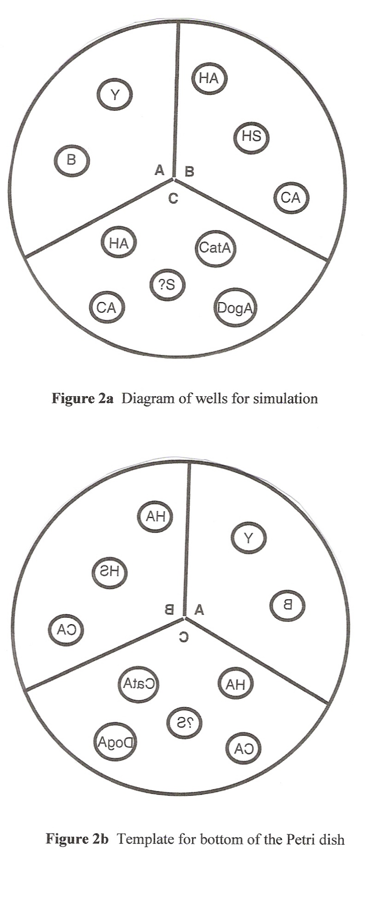
Observing the results
The results should be fully visible in 45 minutes. If the plate cannot be observed at 45 minutes, it can be observed the next day.

Finishing up
At the completion of the lab the Petri Dishes may be disposed of in the trash.

Questions

- What is the difference between antibodies and antigens?
- How does immunological testing work?
- What is the main goal of this particular lab?
- What happened in section A of the Petri dish? What did this section demonstrate?
- What happened in section B of the Petri dish? What was this section meant to show?
- What happened in section C of the Petri dish? What was the purpose of this section?
- Did Bill hit the pedestrian? Explain your answer.
- Describe three possible uses of immunological testing.

Adapted from “Biotechnology on a Shoestring” Template developer – Brian Shmaefsky, Kingwood College

