
Ursinus College

Is a Hydrogen Car in Your Future? Alternative Energy Sources

Standards
3.2.12B, 3.4.10B, 3.7.12A, 3.8.12B & C

Background
Solar panels (“solar cells”) are examples of useful electrical technology, since they convert the sustainable energy of sunlight into electricity. However, we often need electrical power when sunlight is not available; for example, at night time. This means that we want to collect the sun’s energy with a solar panel and store it for later use. If a solar panel is connected to an electrolyzer (fuel cell), the energy of the sun can be used to split water (H₂O), creating hydrogen (H₂) and oxygen (O₂) gases. The process of splitting a compound is called electrolysis. These gases can be stored in the fuel cell, and then used to make electricity when it is needed. The reactions involved are:
Energy + 2 H₂O → 2 H₂ + O₂
2 H₂ + O₂ → 2 H₂O + Energy

The conversion of energy from one form to another is the principle behind any electrical generator, including solar panels, diesel or gas engine generators, hydroelectric turbines and fuel cells. As demonstrated in this experiment, this technology offers an incredible potential solution to the air pollution problem. This concept is already used by astronauts living in the space stations and traveling in the space shuttles. Imagine producing electricity and being able to drink the by-product!
Over the last few decades, car companies have been working on fuel cell cars, producing several prototypes with impressive features. Two auto manufacturers currently offer fuel cell vehicles, the Toyota Mirai and Hyundai Tucson. Both are sold internationally and in California. The Toyota Mirai car can travel 502 km (312 mi) on a full tank, and has a combined city/highway gas mileage of 66 miles per gallon. This makes the Mirai one of the most fuel efficient vehicles rated by the EPA. The Honda Clarity fuel cell vehicle, which will become available by the end of 2017, is predicted to have even better fuel economy. In addition to vehicles for personal use, several police and fire departments in the United States have fuel cell powered vehicles. Some European towns have changed part of their public transportation bus fleet to fuel cell powered busses. Locally, the Southeastern Pennsylvania Transportation Authority (SEPTA) in greater Philadelphia has received a 2.6 million dollar grant to purchase 25 fuel cell electric buses and fast charging stations. In order to mass produce hydrogen fuel cell vehicles, the United States must invest in the installation of hydrogen fueling stations throughout the country.

Guiding Questions
What are some potential positives and negatives to using solar energy?

Other than gasoline, what energy sources could be used to power a motor vehicle?

What are some challenges involved with mass producing non-gasoline powered vehicles?

Equipment
- Fuel cell | - Two patch cords – 1 red & 1 black
- Solar panel | - Model car
- Distilled water | - 500 Watt utility light
- Ruler

Safety and Proper Use of Equipment

- CAUTION: the work lamps get extremely hot. Do not touch the surface of the lamp or stare into it.
- The solar panels are fragile. Do not touch the surface of the solar panel, and use caution not to bend it.
- Do not place the work lamp closer than 20 cm (8 inches) away from the solar panel.
- Use only distilled water in the fuel cells. Regular tap water will ruin the fuel cell!!

Procedure
- Place the fuel cell upside down (numbers facing down) on the flat surface. Remove the stoppers.
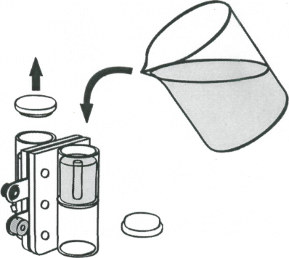
- Pour DISTILLED water into both storage cylinders until the water reaches the tops of the small tubes in the center of the cylinders.
- Tap the fuel cell lightly to help water flow into the area surrounding the membrane and metal current-collecting plates.
- Add more water until it starts to overflow into the tubes in the cylinders.
- Place the stoppers back onto the cylinders. Make sure no air is trapped inside the cylinder.
- Turn the reversible fuel cell right side up.
- Plug one end of the red patch cord into the red jack of the solar panel (1) and the other end into the red jack of the fuel cell (3).
- Repeat step 7 with the black patch cord and the black jacks (2, 4).
- Align the solar panel with the light source keeping a minimum distance of 20 cm (8 inches). Turn on the light. Start your stopwatch.

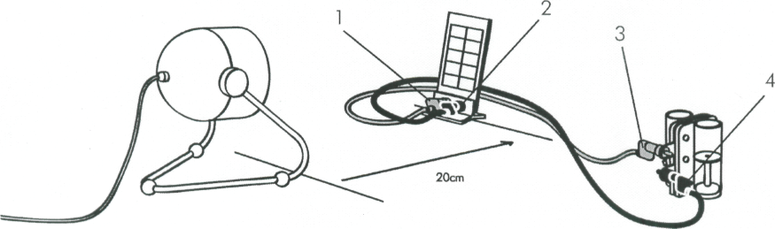

- When the hydrogen storage cylinder is filled to 12 mL, turn off the light and record the exact volume, in mL, of hydrogen gas. Record also the time.
- Unplug the patch cords from the reversible fuel cell.
- With the red and black terminals facing towards the front of the car, place the reversible fuel cell into the notches on the model car until it audibly clicks into place.
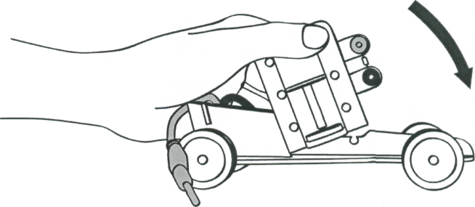
- Connect the red (positive) banana jack with the red (positive) terminal.
- When the car is in racing position connect the black (negative) banana jack with the black (negative) terminal. Start your stopwatch.
- When the car stops moving, measure the total distance traveled and volume of hydrogen gas used on your report form. Record the time.

References
Heliocentris Dr FuelCell Model Car Laboratory Manual, Heliocentris Energiesysteme GmbH, Rudower Chaussee 29, 12489 Berlin, Germany.

Fuel Cell Vehicle. (n.d.) Retried March 18, 2017 from Wikipedia: https://en.wikipedia.org/wiki/Fuel_cell_vehicle

U.S. Dept. of Transportation. (April 2016). U.S. Department of Transportation Announces Projects Selected to Receive $22.5 Million in Grants for Clean Buses, Infrastructure. Retrieved from https://www.transit.dot.gov/about/news/us-department-transportation-announces-projects-selected-receive-225-million-grants-clean

Eudy, L. Post, M. Jeffers. M. (Nov. 2016). Fuel Cell Buses in U.S. Transit Fleets: Current Status 2016. Retrieved from https://energy.gov/sites/prod/files/2016/12/f34/fcto_2016_fuel_cell_bus_report.pdf

Report Form Name: ________________________
Data
Time to make 12 mL of hydrogen gas: __________ min
Time to use up all 12 mL of hydrogen gas: ___________ min
Total distance traveled: _______ m

Post-Lab Questions
- Write the chemical reaction for electrolysis.
- Write the reaction that is occurring within the fuel cell while it is powering the car motor.
- How did the time needed to make the hydrogen gas compare to the length of time the car ran?
- Why are the products of the hydrogen fuel cell reaction preferable to the products of gasoline combustion?
- What other ways could we make hydrogen gas to use as fuel?

Teacher Notes.

The Solar Panels are most fragile. They must not be bent!

Make sure students do not place the artificial light source any closer than the 20 cm noted in the procedure.

Distilled water ONLY must be used in the fuel cells. Students must wash and rinse hands thoroughly before handling the fuel cell. Unwashed and un-rinsed hands contain harmful ions.

Approximate time:
About 15 minutes to set up.
About 15 minutes to charge the fuel cell.
About 10 minutes to “race” the cars.

Can be done in one standard, non-block class period.

Answers to Questions:

Guiding Questions
- What are some potential positives and negatives to using solar energy?
Answers will vary.

- Other than gasoline, what energy sources could be used to power a motor vehicle?
Electricity, solar, biofuels, etc.

- What are some challenges involved with mass producing non-gasoline powered vehicles?
Politics surrounding oil production/consumption and the profits involved, patents, rebuilding car production plants, time and resources for research and design

Post-Lab Questions

- Write the chemical reaction for electrolysis.
Energy + 2H₂O 2H₂ + O₂

- Write the reaction that is occurring within the fuel cell while it is powering the car motor?
2H₂ + O₂ Energy + 2H₂O

- How did the time needed to make the hydrogen gas compare to the length of time the car ran?

Variable, but often takes longer to make the hydrogen than to use it up.

- Why are the products of the hydrogen fuel cell reaction preferable to the products of gasoline combustion?

Water is not harmful to the environment and gasoline engine emissions such as nitrogen gas, carbon dioxide, carbon monoxide, hydrocarbons and nitrogen oxides are contributing to global warming.

- What other ways could we make hydrogen gas to use as fuel?

Could use fossil fuels for energy to split water, but that almost defeats the point of the fuel cell- only potential benefit is that it concentrates pollution into one location that can be more easily regulated that car exhaust. Some research into growing bacteria that can produce hydrogen as a biological process.

