Energy of a Tossed Ball
Name:

Partner’s Name:
When a juggler tosses a bean ball straight upward, the ball slows down until it reaches the top of its path and then speeds up on its way back down. In terms of energy, when the ball is released it has kinetic energy, KE. As it rises during its free-fall phase it slows down, loses kinetic energy, and gains gravitational potential energy, PE. As it starts down, still in free fall, the stored gravitational potential energy is converted back into kinetic energy as the object falls.
If there is no work done by frictional forces, the total energy will remain constant. In this experiment, we will see if this works out for the toss of a ball.
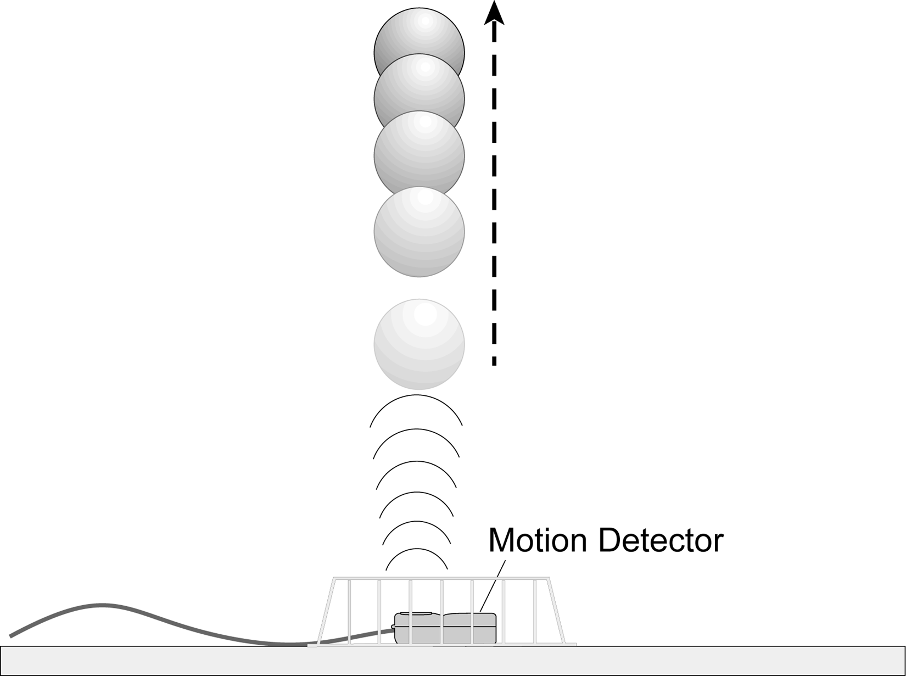
In this experiment, we will study these energy changes using a Motion Detector.
objectives
- Measure the change in the kinetic and potential energies as a ball moves in free fall.
- See how the total energy of the ball changes during free fall.

Materials
LabQuest  LabQuest App | volleyball, basketball, or other  similar fairly heavy ball
Motion Detector | wire basket

Preliminary questions
For each question, consider the free-fall portion of the motion of a ball tossed straight upward, starting just as the ball is released to just before it is caught. Assume that there is very little air resistance.
- What form or forms of energy does the ball have while momentarily at rest at the top of the path?
- What form or forms of energy does the ball have while in motion near the bottom of the path?
- Sketch a graph of velocity vs. time for the ball.
time
v
- Sketch a graph of kinetic energy vs. time for the ball.
time
KE
- Sketch a graph of potential energy vs. time for the ball.
time
PE
- If there are no frictional forces acting on the ball, how is the change in the ball’s potential energy related to the change in kinetic energy?
Procedure
- Measure and record the mass of the ball you plan to use in this experiment.
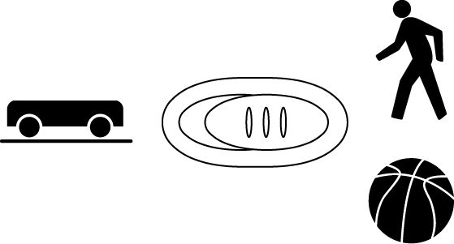
- If your Motion Detector has a switch, set it to Normal. Connect the Motion Detector to DIG 1 on LabQuest and choose New from the File menu. If you have an older sensor that does not auto-ID, manually set up the sensor.
- Place the Motion Detector on the floor and protect it by placing a wire basket over it.
4. In this step, you will toss the ball straight upward above the Motion Detector and let it fall back toward the Motion Detector. This step may require some practice.
- Hold the ball directly above and about 0.5 m from the Motion Detector. Use two hands. Be sure to pull your hands away from the ball after it starts moving so they are not picked up by the Motion Detector.
- Start data collection.
- Wait one second, then toss the ball straight upward. Be sure to move your hands out of the way after you release it. A toss of 0.5 to 1.0 m above the Motion Detector works well. You will get best results if you catch and hold the ball when it is about 0.5 m above the Motion Detector.

5. After data collection is complete a graph of position vs. time and velocity vs. time will be displayed. Repeat Step 4 if your position vs. time graph does not show a region of smoothly changing distance. Check with your instructor if you are not sure whether you need to repeat the data collection. To repeat data collection, start data collection when you are ready to toss the ball.
Data Table
Mass of the ball | (kg)

Position | Time | Height | Velocity | PE | KE | TE
 | (s) | (m) | (m/s) | (J) | (J) | (J)
After release
Between release and top
Top of path
Between top and catch
Before catch
Analysis
- To analyze only the free-fall portion of the data you must zoom in on the graph.
- It is easiest to select the proper region using the velocity graph.
- To select the free-fall portion of the data, tap and drag your stylus across the straight-line, negative-slope region that corresponds to free fall.
- Choose Zoom In from the Graph menu to display just that portion of your graph.
- To explore the energy of the ball (kinetic and potential) at various moments during the motion, you can examine the graph by tapping any data point. As you tap each data point, time and velocity values are displayed to the right of the graph. Record the following times and velocities in your data table: Tap the point at the moment just after the ball was released into free fall, then when the ball was at the top of the path (where velocity was about zero), and then just before the free-fall motion ended. Choose two more points approximately halfway in time between the three recorded so far. You should now have five times and velocity data pairs.
- Using the position graph, determine the position of the ball at the same five times you used in the previous step. Record the position values in the data table.
- For each of the five points in the data table, calculate the Potential Energy (PE), Kinetic Energy (KE), and Total Energy (TE). Use the position of the Motion Detector as the zero of your gravitational potential energy.

2. How well does this table you have just completed show conservation of energy? Explain.
You can also graph the ball’s energy at all the measured times, instead of just the five in the data table. Using the position data in the equation mgh, you can store gravitational potential energy at each moment in a new column. Using the velocity data in the equation ½mv², you can store the ball’s kinetic energy in another new column. Finally, you can find the total mechanical energy at each moment by finding the sum of the potential and kinetic energies and storing the data in a third new column.
3. Display a single graph by choosing Show Graph from the Graph menu and selecting Graph 1.
4. Calculate the ball’s gravitational potential energy (PE) using mgh, where the height h comes from your distance data, storing the result in a new column.
- Tap Table to display the data table and choose New Calculated Column from the Table menu.
- Enter the Name (PE) and Units (J).
- Select the equation, ABX.
- Select Position as the Column for X.
- For the A value, enter the mass of the ball in kg.
- For the B value, enter 9.8.
- Select OK to display the graph of potential energy (PE) vs. time.

5. Inspect your potential energy vs. time graph for the free-fall flight of the ball. Explain its shape.
6. Print or sketch the potential energy vs. time graph.
7. In a similar way you can calculate the ball’s kinetic energy.
- Tap Table to display the data table.
- Choose New Calculated Column from the Table menu.
- Enter the Name (KE) and Units (J).
- Select the equation, ABX^C.
- Select Velocity as the Column for X.
- For the A value, enter 0.5.
- For the B value, enter the mass of your ball in kg.
- For the C value, enter 2.
- Select OK to display the graph of kinetic energy (KE) vs. time.

8. Inspect your kinetic energy vs. time graph for the free-fall flight of the ball. Explain its shape.
9. Print or sketch the kinetic energy vs. time graph.
10. Compare your energy graph predictions (from the Preliminary Questions) to the real data for the ball toss.
11. Calculate the ball’s total energy KE + PE and store the result in a third new column.
- Tap Table to display the data table and choose New Calculated Column from the Table menu.
- Enter the Name (TE) and Units (J).
- Select the equation, X + Y.
- Select KE (J) as the Column for X.
- Select PE (J) as the Column for Y.
- Select OK to display the graph of total energy (TE) vs. time.

12. Display all three energy plots on the same graph.
- Choose Graph Options from the Graph menu.
- Select PE, KE, and TE for the Graph 1 Y-Axis.
- Select OK to display a graph of PE, KE, and TE.
13. Tap and drag your stylus across the free-fall portion of the data. Choose Zoom In from the Graph menu to display just that portion of your graph.

14. What do you conclude from the total energy vs. time graph about the total energy of the ball as it moved up and down in free fall? Does the total energy remain constant? Should the total energy remain constant? Why? If it does not, what sources of extra energy are there or where could the missing energy have gone?
Extensions
- What would change in this experiment if you used a very light ball, like a beach ball?
- What would happen to your experimental results if you entered the wrong mass for the ball in this experiment?
- Try a similar experiment using a bouncing ball. You should mount the Motion Detector high and pointed downward so it can follow the ball through several bounces.

