Antara Dabral
Anthropology of Sexuality
The Actions of a Lonely Woman and the Effects of
Online Incel Communities on Society
Introduction
In recent decades, movements such as women’s rights have started to give disadvantaged groups in society the same rights and abilities as everyone else. Unfortunately, this has historically been met with pushback from opponents who were used to the way society was. This can be seen through various historical events in multiple countries, such as women’s suffrage in the United States. Pushback to such movements stems from the disruption of the status quo and the deviance from the gender roles society casts people in.
In more recent years, the resistance to women’s rights movements has started to shift from only being based on gender roles and has started to take root in insecurity and anxiety surrounding a dating life. This phenomenon has been further exacerbated with the advent and growth of the internet, where ideas are allowed to spread across the world rapidly which has created online forums where people known as incels gather, and the algorithm which shows users items related to their search history or to the posts they have liked.
In this paper, I ascertain that these online forums have a broad incel culture and community founded on victimhood and frustration and how they were formed as a consequence of a well-intended action, then investigate how language and terminology in various online spaces affect different incel cultures and how that language has created the “alpha/beta male”, “Chad”, “Stacy/Becky”, and “nice guy” stereotypes, and then examine how incel culture relates to broader issues such as mental health, violence against women, homophobia, transphobia, and ableism. Lastly, I will discuss the experiences of people who try leaving.

The Incel Community History and Legitimacy
A community has multiple definitions including “a unified body of individuals such as: the people with common interests living in a particular area, a group of people with a common characteristic or interest living together within a larger society, a body of persons of common and especially professional interests scatters through a larger society, a body of persons or nations having a common history or common social, economic, and political interests, a group linked by a common policy, an interacting population of various kinds of individuals in a common location, or a state or commonwealth” (Merriam-Webster, 2019). One can argue that the online incel forums technically fit all these definitions, however one definition undeniably fits the online incel forums. It is the second definition in the Merriam-Webster dictionary: “common character: LIKENESS” (Merriam-Webster, 2019). Online incel communities are alike in that they have a common traceable history which ties into the men’s rights movement and victimhood.
In the 1970s, a men’s liberation movement occurred because of second wave feminism. It was an awareness campaign for recognizing the struggles women faced and for getting rid of the stereotypes forced on men, which broke off into two different groups: a pro-feminist movement which focused on gender relations, and a men’s right movement which focused primarily on the issues that gender roles cause to men and ended up becoming an anti-feminist group (Messner, 1998). The men’s rights movement consists of people who believe that power dynamics in society favor women and work against men, especially in terms of a dating life and relationships.
The people we call Incels today fell under this group of men but were not called incels until a woman called Alana created the term “involuntary celibates”. She created the term to refer to people of any gender who used her website that was designed to help anyone who felt lonely, were virgins, or were single for a very long time. Over time, Alana stopped using her online forum, her term got shortened to “incel”, and her forum’s purpose changed to being a gathering place for heterosexual men to spread misogyny. The online incel community gradually grew and various forums popped up on websites such as 4Chan, Reddit, 8Chan, Gab, Incel.me, and etc (Labbaf, 2020). Inside these oftentimes anonymous online forums, incels will feel safe and emotionally connected via their views on women and other minority groups. Depending on the forum, incels have rallied around certain people such as Elliot Rodger, a self-identified incel with a prominent YouTube channel and a widely shared 130+ paged manifesto, who killed around 6 people and injured 14 in 2014 with the intentions of murdering the hottest girls at his college who just happened to be members of Alpha Phi sorority. An interesting fun fact is that there are t-shirts of Elliot Rodger wearing sunglasses that have been and are being sold (BBC, 2018).

General Incel Beliefs, Terminology, and Relations Within the Manosphere
To discuss the general Incel beliefs and language, there must be an understanding of the online presence of the Men’s Rights Movement, which is otherwise known as the manosphere. The manosphere is a social system comprising of various misogynistic groups including incels, fathers’ rights groups, Men Going Their Own Way (MGTOW), and Pick Up Artists (PUA) that influence each other’s beliefs and language (Crăciun, 2022). A key component of the belief systems of all groups in the manosphere is known as the ‘red pill’ which is a reference to the Matrix, because the red pill is supposed to reveal the truth. In this case, the ‘truth’ is a belief that feminism negatively impacts society (Ging, 2017). Most notably, it seems as if PUA has had the most influence on Incel cultures in comparison to the other groups that exist in the manosphere. It is an interesting phenomenon because while both cultures have commonalities in misogyny, the PUA culture frames women as a sexual resource that men need to learn how to control, whereas incel culture involves rage that blames women for the PUA’s pick up strategies not working (Crăciun, 2022).
Generally, incels and members of the PUA believe in a slightly complicated view of the current societal dynamics between men and women in comparison to misogynists of the past decades. They believe that women are biologically geared towards wanting sex with ‘alpha males’, otherwise known as dominant males. The men who cannot get sex are therefore seen as ‘beta males’, who are weak. In their views a woman will ‘shit test’ a man by instinct because an ‘alpha’ will demonstrate the ability to defend her by fighting with her, whereas a ‘beta’ will not (Ging, 2017).
This dichotomy has created other terms that originated in the PUA community, but then spread to the incels, including: cuck, negging, friendzoning, going caveman, the bitch shield, and pawning. A ‘cuck’ is a man whose girlfriend cheats on him, typically with a black man. ‘Negging’ is when a man gives a woman a backhanded compliment meant to destroy confidence to assert dominance. ‘Friendzoning’ is when a woman sexually or romantically rejects a man because she views him as a friend. ‘Going caveman’ means that a man is asserting dominance over a woman, ‘bitch shield’ is any woman’s defense against unwanted male attention, and ‘pawning’ is using a conventionally attractive woman to enhance a man’s sexual market value (Ging, 2017).
In addition to the terms, there are also certain stereotypes that are widely used in online incel communities that I personally know of from prior experience on social media platforms include the ‘Chad’, ‘Stacy’, and ‘Becky’. A Chad is an ‘alpha’ man that all women want. He is perfect in all the traditionally masculine ways; he looks like a supermodel, might be rich, is extremely dominating, and is emotionally unavailable. A ‘Stacy’ is often a hyperfeminine woman. She has big boobs and a big butt, is usually a blonde, always has attention but wants alone time, lives in luxury, instantly gives men erections, shows off her body online because she can make money from ‘virgin losers’, and only has sex with ‘Chad’. She may or may not hate ‘Becky’. ‘Becky’ refers to women who are feminists and want to dominate others. She will focus on college to enhance her career, is needy, believes guys like the ‘natural look’, has some attention from ‘beta’ males, has small boobs and a small butt, will dye her hair green or blue, will post provocative pictures to get attention, and wants sexual intercourse with ‘Chad’. The creation of these stereotypes indicates that incels believe that all women want the perfect man and that none will go for anything less than a ‘Chad’.
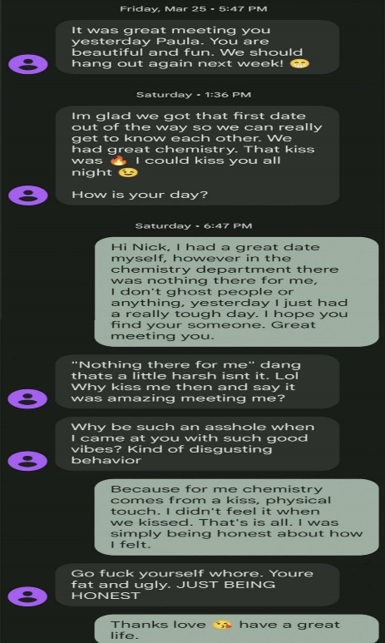
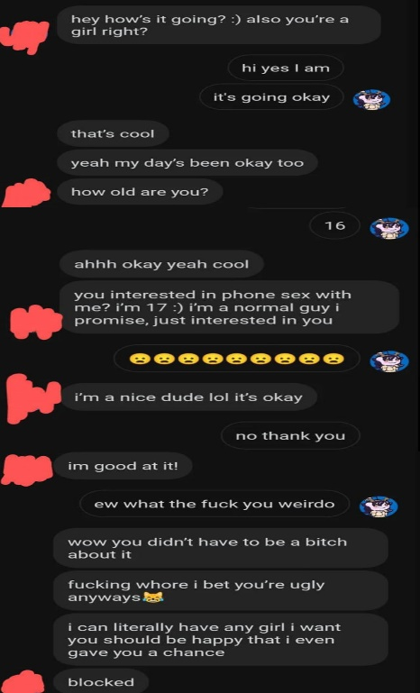
Another stereotype I am familiar with due to being online on social media and reading stories of other women’s interactions with men online is known as ‘the Nice Guy’. It is a tactic in which a man will deliberately be kind and do nice actions for a woman and expect a reward in return for doing the bare minimum. The stereotype within the incel and PUA communities tends to lean more towards believing that a ‘nice guy’ is misunderstood and will get friendzoned, or manipulated by women into doing things for them with no reward in return (Crăciun, 2022). It shows that these communities view being a ‘nice guy’ is alike to being a ‘beta male’ who does not get any sexual or romantic action. However, there have been multiple instances in which women have been approached by a ‘nice guy’ who when rejected starts threatening and insulting them, as seen in figure 1.
Fig 1. (Left) Image from buzzfeed.com showing how the ‘Nice Guy’ behaves.
(Right) Image from yahoo.com also showing how the ‘Nice Guy’ behaves.
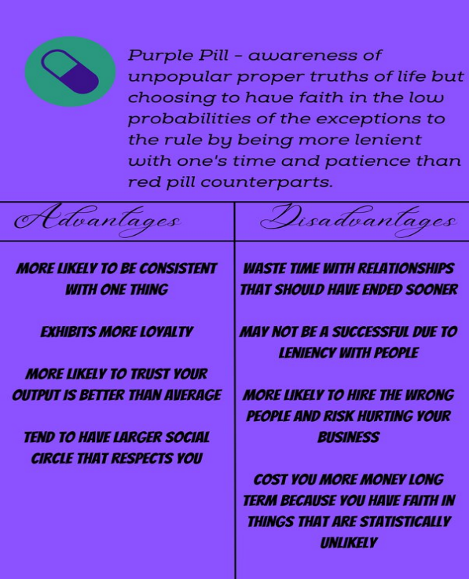
There are a few more important terms within the incel community that I have learned about by asking around in a subreddit called r/IncelExit, which is a group of people dedicated to exiting the incel mindset or helping others leave that mindset. One person, whom I shall call Sunshine as they do not want their reddit name to be shared, told me more about the Red Pill, and informed me that there are more pills. According to Sunshine, the Blue Pill is the belief that most people have in which personality and confidence are the most important and easily fixed, and that women do not usually care about looks. The Red Pill is the belief that wealth, flirting skills, looks, and social status matter a lot to women, and that these are fixable with hard work. Then there are the Black and Pink Pills, which are essentially the same idea but from different genders. The Black Pill is the idea that looks and genetics are the only factors that matter and they are unchangeably since birth, and the Pink Pill is the Black Pill but specifically for femcels. It is interesting that there are different types or levels of beliefs in terms of optimism with their dating chances, and according to users in the r/IncelExit thread, different websites usually subscribe to either the Black or Red pills¹¹. There also appears to be a term called a Purple Pill in which people who have been exposed to Red Pill ideas still try to date with some Blue Pill ideas (fig 2).
Fig 2. An infographic from quora.com detailing the Purple Pill ideology and the pros and cons of it.
My interview with Sunshine also brought to light that within the different online websites, there are some key differences in how they behave. For example, on incel.is, which according to multiple people on r/IncelExit is the most prominent incel space, the guys believe there is no point in trying because they are not ‘Chads’ and have created abbreviations such as Lay Down and Rot (LDAR). The meaning of this phrase is to feel hopeless about circumstances and do nothing. Whereas on online spaces like looksmax.org, men are still trying to become ‘Chad’ and may at times encourage getting extreme surgeries such as leg lengthening (Sunshine, Personal correspondence).
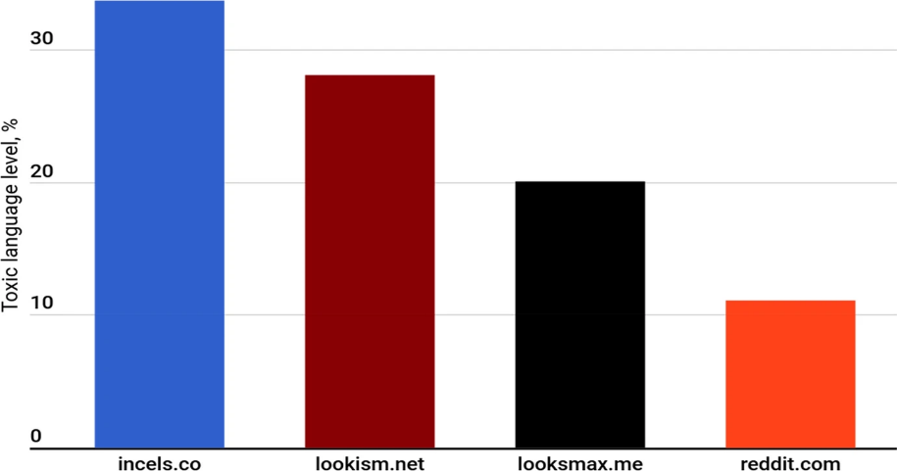
A study done by Pelzer et al. (2021) investigated the toxicity of the languages used in three different incel websites, in comparison to on Reddit which has more recently banned subreddits relating to the word incels and relating to any directly misogynistic behaviors. They examined incels.co, which rebranded into incel.is, lookism.net, and looksmax.me. Due to the large volume of posts and users, an automated filtering system was created to detect toxic language which also requires acknowledging that there are different definitions of toxicity and that the different websites have different rules. The researchers decided to base their system on Google’s BERT which is a language model and network that was trained by Wikipedia and thousands of books on the relationships between words. As seen in figure 3, incels.co had a toxicity level of 33.7%, lookism.net was at 28.1%, looksmax.me clocked in at 20.1%, while Reddit was at 11.1% .
Fig 3. Levels of toxicity between 3 different incel spaces compared to Reddit as determined by an automated system that perused thousands of posts.
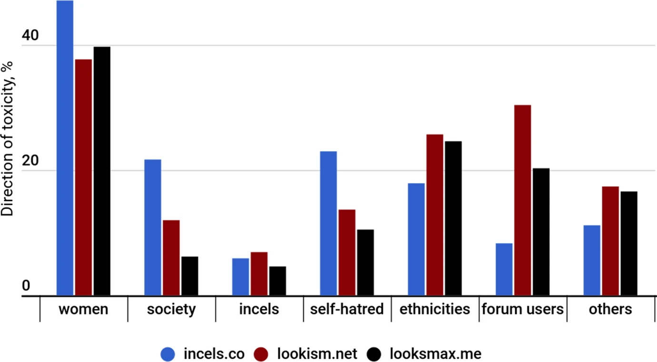
Furthermore, the toxicity was divided into categories based on who the target is in figure 4. Hatred towards women was the leading form of toxicity on all three websites; however there were differences in self-hatred, racism, forum users, and others between the three websites (fig 4). The differences in the purposes of these websites might account for the differences in the types of toxicity. Incels.co known to lean into more of the Black Pill philosophy than the other two websites, so that could be a reason why they show the most hatred towards society and themselves. Lookism and Looksmax lean more towards Red Pill philosophies, and users are more encouraged to share selfies and rate each other, which could be a reason why racism, hatred towards other forum users, and other forms of toxicity are higher than Incels.co (Pelzer et al., 2021).
Fig 4. The various targets of toxicity within these three incel communities and the degrees of toxicity.⁸
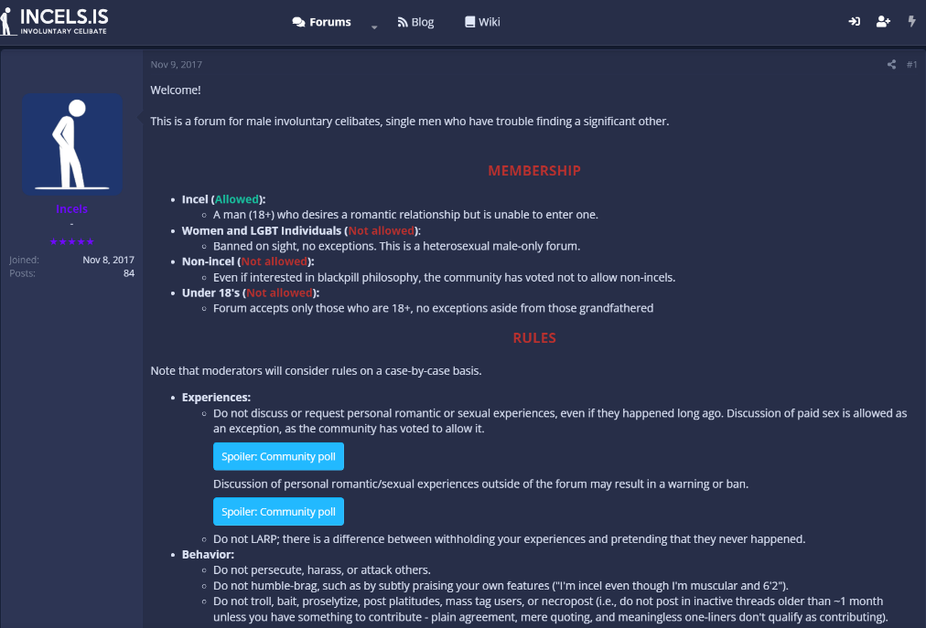
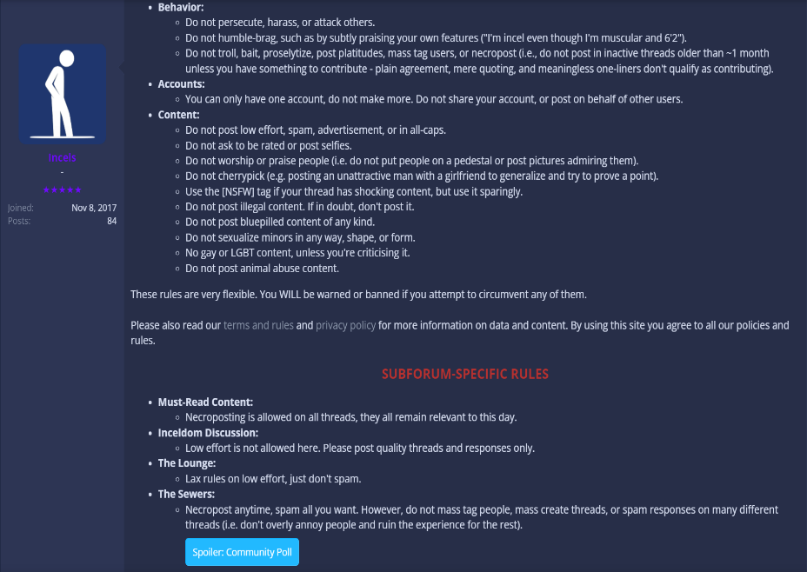
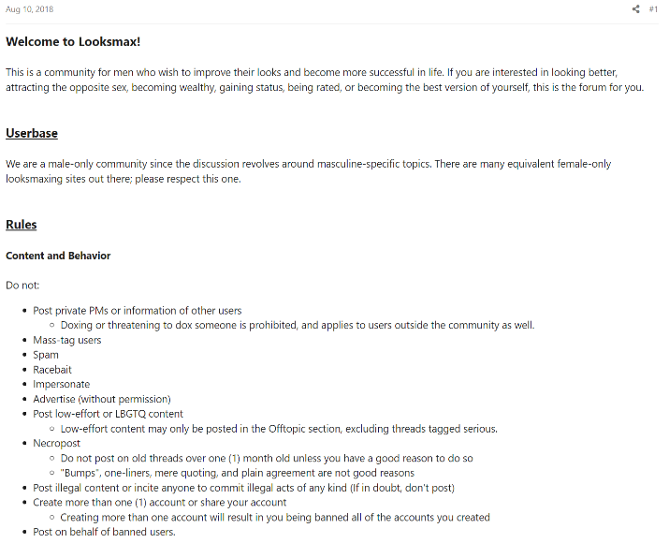
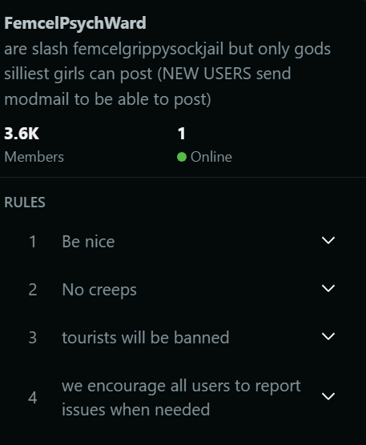
Another, less quantitative way, of seeing the differences in the incel and incel adjacent websites, or subgroups on popular social media, is to look at the rules of the forums. In figure 5 (below), one can see the differences in ideologies between several different incel areas in comparison to each other, even on websites and social media that stringently monitor hate speech and incel behavior. Some of these online spaces I found due to formal research done on them, and others I found by going through reddit, Wikipedia, and google.
Fig 5. (Top left) Rules from a subreddit called r/FemcelPyschWard. (Bottom left) Rules on Looksmax about the userbase and content. (Right) The extensive membership and content rules of incels.is
Relations Between Incel Beliefs, Mental Health, Porn, Violence Against Women, and LGBTQ+
No matter which incel space is examined, the common baseline is self-depreciation and blaming women. A lot of incels, prior to and in the process of becoming incels, experienced issues with dating and would often get rejected which contributed to a decrease in mental health, especially with the prevalence of dating apps. Most incels seem to live in Western Nations, such as countries in Europe and North America, and more incel-posts were created from people living in communities where there were more men than women. The incel posts were notably higher when a community had more men, higher income inequality, and lower gender income gaps. Additionally, on dating apps incels matched with 4.5% of women compared to non-incels matching with one third of the women they swiped on and incels had higher reports of being ghosted online. When compared to the national average for reports of depression and anxiety (28% and 36%), the prevalence rates were 95% and 93% respectively, and most incels reported experiencing social isolation as well. The way that incels cope with these mental problems is by engaging in solitary behaviors like weightlifting and concerning behaviors like watching pornography (Sparks et al., 2022).
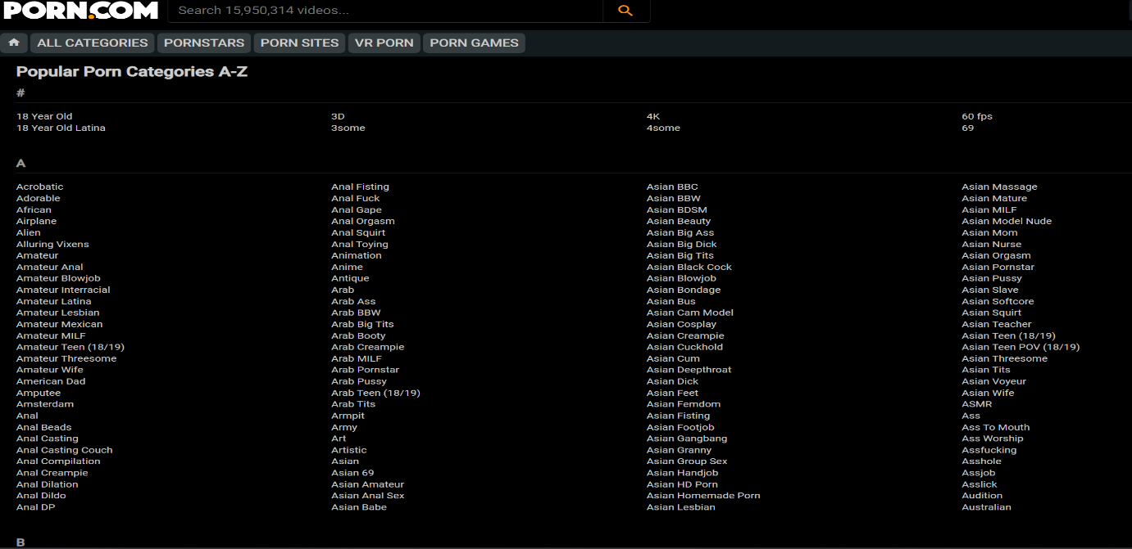
Pornography is an extremely addicting genre of film that is unfortunately extremely problematic in multiple ways but most pertinent is the way it portrays certain groups like women. Pornography when it includes women tends to dehumanize women, similar to how incel beliefs dehumanize women, and so it is hard to know if porn is how incels learn about heterosexual relations or if porn is used by incels against women (Tranchese & Sugiura, 2021). The dehumanization can be seen in figure 6 below where women are categorized like commodities. These types of dehumanization, although shown in different ways, only further adds to the misogynistic mindsets.
Fig 6. A small example of the different categorizations available on porn.com, which is mostly catered towards heterosexual men.
The extremes of the incel mindset are seen in mass murderers such as Elliot Rodgers, whose story resonated with the incel communities across the web at large. Since his day of retribution, more self-identified incels and suspected incels have been murdering innocent people. People were able to relate to Elliot Rodgers because of his youtube channel, incel forum posts, and manifesto that detailed every single perceived wrong that was done to him by multiple people. The issues he faced in his life had to do with rejection, social isolation, and frustration which is a prevalent theme in incel communities (O’Donnell, 2021).
An interesting part of the online incel communities involve even more isolated groups called femcels or gaycels. Traditionally, incels usually consist of heterosexual males, many of whom do not believe that femcels or gaycels can exist. A lot of it has to do with misogyny and anti-LGBTQ+ sentiments. The usual incel believes that because women will always have a man who wants her even if she has insecurities and is not a ‘Stacy’ but she might be celibate because of having high standards. In terms of how they view gaycels, while ignoring the anti-LGBTQ+ sentiments, it is probably because incels have this belief that men are not super picky about their partners and therefore a gay person should not have any issues with dating. For transgender people, transwomen are women and therefore cannot be incels, and transmen are born as women and therefore cannot be incels. Moreover any form of disability is viewed as something to hate or pity because so many incels themselves tend to have issues like autism (Sunshine, Personal Correspondence). Not much research has been done on gaycels due to the low occurrences of them but I believe they also share common themes of hating society. The low occurrences of them could be attributed to LGBTQ+ people having a community that they could turn to for support in extension of their gender or sexual orientation.

Femcels History and Beliefs
Not much research has been done on groups like Femcels. Until 2021, there was a subreddit called r/Trufemcels which was for femcels to gather in a community. When the subreddit was banned, a user named Giga created ThePinkPill.co, which is now completely shut down. Some femcels still remain on a subreddit called r/ForeverAloneWomen, but Forever Alone Women are not necessarily femcels. Femcels believe that they can’t find sex and love because they are ugly and lack social skills. They also blame lookism. Lookism is a term to describe how society discriminates based on appearances. Like incels, some femcels believe they can change their looks whilst others are resigned to their perceived fate of ugliness. Like incels, a lot of the same stereotypes have been adopted into the femcel community. However, there has been a shift in what femcel means. As of 2022, the term femcel has shifted to being based off a ‘sad girl’ aesthetic in which toxic self-destructive feminine traits are encouraged. The newer femcels seem to idolize people like Lana Del Ray, who often sings about her struggles and depression. This seems to be encompassed in the feminist movement, by women who are disillusioned with the hyper-optimistic portrayal of ‘girl power’ and ‘girl boss’. As such, in both the old and new sense of the word, the women turned towards femcel communities to help them cope with their feelings of loneliness and depression. And like incel communities, the femcels also demonstrate extreme frustration, but they will blame men and women who are doing better than them in their eyes (Rasmussen & Johansson, 2023).

Trying to Leave
I have mentioned previously that I asked questions on a subreddit called r/IncelExit, which has provided me with a lot of useful information about how people get sucked into the incel mindset and how hard it is to leave. Sunshine was kind enough to detail their years of experience in the incel community and their experience in leaving. They are still in the process. I began with asking how they became an incel.
“I discovered the incel movement on places like 4chan in the 2000s/2010s, when the movement was still just beginning. At first, I looked at it out of curiosity and to laugh at the material. Eventually it started fucking with my mind and how I viewed dating and relationships. The progression was slow. I started viewing incel-adjacent material in 2004, when I was in middle school or early high school. I was given too much freedom on the internet as a kid. I did not become an incel until 2014.” I then asked how many incel spaces did they use, and if the levels of toxicity were different.
“I used quite a few; incels.is, looksmax.org, Neet forums, and Sanctioned Suicide. The toxicity was the same in those forums mostly. On incels.is, the guys gave up and created the LDAR abbreviation for Lay Down and Rot, but on forums like looksmax.org men were getting dangerous surgeries such as leg lengthening to become more like ‘Chad’. The four sites I used have a lot of overlap in the users and some are moderated by the same people.” I then asked about femcels, LGBTQ+, and disability in those spaces.
“According to those forums, femcels do not exist. Only Sanctioned Suicide would allow women in. Incels believe that self-proclaimed femcels will not settle for their looksmatch, or someone who is equivalent to them in looks. Queerness was not allowed at all because those forums believed that queer people can easily get sex and love. As for disability, the incel community is extremely ableist because many of those guys have some form of disability and that is an insecurity for them. In fact, according to the Black Pill, autism is the worst curse a man could have because all women are repulsed by autism and hate autistic men. Oh, and there is this practice that some incels practice called transmaxxing. They will turn into a woman so they can become lesbians and have sex with women.” I then asked them to clarify if a transwoman or transman would be allowed into those spaces, and “a transwoman is a woman so she would not be accepted, and a transman was born as a woman so he would not be allowed either.” Next I asked about if Sunshine ever participated in the toxicity, how bad it got, and to describe their process of leaving.
“For women, I never went all out and wanted to take away their rights or anything like some do. I thought women hated all men who weren’t ‘Chads’ and wanted me dead. I was afraid of women in my own age group, and I still somewhat am. For LGBTQ+ people, I never crossed that line. I had an uncle who I was really close to and he was gay. I could not stand the homophobia in a lot of the incel communities, and it was the same with the ableism. I have various mental disorders and I could not get behind the ableism, and there was a lot of racism that I could not agree with as well. There were many things that made me want to leave, but I couldn’t. I felt very excluded because a lot of the guys would put me down a lot and make fun of me for not being extreme enough, but I felt trapped because I felt I was subhuman and had no place in society because of my looks and disabilities. It just seemed so rational to me even though I hated it. Last spring, I knew if I kept going like that, I was going to end up killing myself. It had to stop. I have been in recovery for seven months now, and it is a very slow process. I have been doing a lot of therapy and have been looking into cult deprogramming online, since I was basically in a cult.”
Sunshine’s story holds many similarities with the brief stories I heard about others who I had the fortune of meeting on r/IncelExit. Though there are variations to their stories, they all have common themes of being sucked into the incel communities gradually either by talking to certain people on Discord or 4Chan, watching certain right-wing content on youtube, or simply interacting with posts that relate to some insecurity that they might already have. Then they gradually get exposed to more incel-related content because the algorithms on the internet see what content they liked or interacted with, then look at what the other users (who have interacted and liked the same content) also view and interact with, and then bring that content up to increase user engagement. And this user data can and has been shared with other websites regardless of whether it was unintentional or not.
Then getting out of the incel mindset becomes hard, because their insecurities and depression has only gotten worse over time, others will ostracize them for being incels in the first place, and they are losing a community that they were once a part of. In fact, as I was researching for this paper, I found myself thinking back to who I was in high school or middle school. If I was exposed to this content at that phase of my life, I would have sympathized and strongly related with an alarming amount of those posts. Even now there were a few posts that were relatable to me because of my own self-esteem issues and that shows how easy it is to get pulled in. The impacts of the incel mindset have caused those leaving that community to need extensive therapy.

Conclusion
The incel presence online is, by itself, one massive community with related cultures surrounding the hatred of women as the most basic and common belief. They all originated from one woman named Alana who wanted to create a space for all lonely people and has drastically changed in the last 26 years of existence, with one main group diverging from the intended purpose, the communities that was call Incels. Other groups have also been formed such as Femcels and Gaycels but they have not been as researched as much and are not as prominent. Within the incel forums and websites, there are similar degrees of misogyny, self-hatred, and ableism. There are also some differences across the websites regarding the extremity and which Pill philosophy they subscribe to. But all the incel communities, and by extension the femcel and likely gaycel communities, have increased struggles with self-image, depression, and frustrations due to loneliness. This combination, within specifically the incel communities, has encouraged men to commit murder and then kill themselves such as Elliot Rodger. The misogyny seen in incel communities did not necessarily start there, as seen by how the PUA’s linguistics and stereotypes are pervasively used in the incel community. The way these men end up, due to slowly turning into an incel by being exposed to incel-related content over extended periods of time, causes interactions with women, disabled people, and LGBTQ+ people to be extremely toxic and threatening, and when they realize how much their incel ideologies hurt themselves mentally it becomes very hard to recover.

References
- Merriam-Webster. (2019). Definition of COMMUNITY. Merriam-Webster. https://www.merriam-webster.com/dictionary/community. I used this to give a definition to the word community.
- MESSNER, M. A. (1998). The Limits of “The Male Sex Role.” Gender & Society, 12(3), 255–276. https://doi.org/10.1177/0891243298012003002. This source gives some historical context behind the men’s liberation movement and the men’s rights movement.
- Labbaf, F. (2020). United by Rage, Self-Loathing, and Male Supremacy: The Rise of the Incel Community. INvoke, 5. https://doi.org/10.29173/invoke48979. This article examines the usage of the internet in creating communities of people based on ideology, lifestyle, and political movements. These kinds of communities can be beneficial, neutral, or detrimental to the wellbeing of society such as the online fringe group movement known as the incels. This group of people are identified by their widespread hate-fueled reactions to feminism which has allowed for attacks against women, and self-loathing. These two dichotomies in their thinking is a dangerous combination, as it creates the belief that women view these people as inferior and thus choose not to date or be involved with people such as this. This primary belief in turn leads people to hate that women have autonomy and self-empowerment, via feminism, and thus makes them wish for a full-on patriarchy in which only men have autonomy and women are then subservient and have no autonomy in any part of their life. In fact, it leads to women being viewed as objects, due to this group’s desire for control and company. Thus this article examines whether or not the pillars that incels believe in can in fact be defined as a community or culture.
- BBC. (2018, April 25). Elliot Rodger: How misogynist killer became “incel hero.” BBC News. https://www.bbc.com/news/world-us-canada-43892189. This news source provided information on the mass murderer Elliot Rodger.
- Crăciun, M. (2022). Not #MeToo: The Seduction Community’s Nice Guys, Bad Apples, False Allegations and Anxiety. Analele Universităţii Din Bucureşti. Seria Ştiinţe Politice, XXIV(2), 123–153. https://www.ceeol.com/search/article-detail?id=1168945. This article examines a dutch community, known as the dutch seduction community to provide an in-depth understanding of the members and their views of the #metoo movement. This community is aimed towards men who lack the social skills to get into a relationship, and is a part of the men’s rights movement. They try to help men fulfill this view of masculinity, in which men initiate endeavors to gain control and power over intimate relationships. It aligns with the view that the success of sexual endeavors further heightens a man’s masculinity and his social standing. It also is intended to reduce the anxiety these men feel by trying to help them pick up women. The author examines how these men view the me too movement in relation to their own quest for control and power in regards to intimacy. It also involves the examination of certain phenomena such as the existence of the “nice guy” and the ties it has with misogyny. .
- Ging, D. (2017). Alphas, Betas, and Incels: Theorizing the Masculinities of the Manosphere. Men and Masculinities, 22(4), 638–657. https://doi.org/10.1177/1097184X17706401. This article analyzes the intricacies in the new incel communities which have evolved pretty quickly over time. These kinds of communities have a “red pill” type of philosophy, which is to say: they do not believe in feminism, and in fact believe that feminism is the root cause of most of their issues. This article brings into light the complex views of who is actually in charge, with the relatively recent involvement of terms like “beta males” which further victimizes, whether self or involuntarily, incels. It also goes over how this form of misogyny is different to those in the past, especially with the advent of social media allowing a space for these people to create an echo-chamber of sorts. These various communities across the internet are collectively known as the “manosphere” and appear to be the champions of men’s rights in Western culture, which brings into question of how did this evolution occur, why, and who is really in power and who stands to benefit from these online and offline communities. .
- O’Donnell, K. (2021). Incel Mass Murderers: Masculinity, Narrative, and Identity . Ohio Communication Journal, 59, 64–76. Within this article, the author examines how views of masculinity influence some people within the incel communities to become mass murderers. She looks at how various incels actually idolize Elliot Rodger, a man who went on a killing spree in south California and identified as an incel. He later became a martyr for certain incels and committed suicide. These men then use Elliot Rodger’s story as a sort of blueprint upon which they share their collective experiences with their dating lives and women and frame their beliefs that women are to be blamed for their issues with loneliness, rejection, and manliness. And because they idolize Elliot Rodger, they then view murdering women as an action that gives them redemption for the rejections and loneliness that occurred to them. The reason why so many incels related on a personal level with Elliot Rodger, and idolized him, was because they overall feel wronged by society, especially within the framework of having masculinity and manhood, which to them is signified by the ability to have heterosexual sex.
- Pelzer, B., Kaati, L., Cohen, K., & Fernquist, J. (2021). Toxic language in online incel communities. SN Social Sciences, 1(8). https://link.springer.com/article/10.1007/s43545-021-00220-8. This article looks at how incel culture has evolved over the last few decades. Specifically, the authors examine the toxic languages used in a few incel communities to view the effects of language on overall toxicity in different large scale online incel forums. They draw their specific data from incels.co, lookism.net, and looksmax.me. By researching three different well-known incel forums, the authors determined that although toxic language has been used pervasively within all of these forums, there are still completely different components within the toxicity of each forum, which indicate that there are enough differences within the broader incel community and incel culture to further divide it into different incel cultures and communities. It indicates that there is nuance in the beliefs of incels as a whole, in spite of the beliefs that they are infamously known for outside of incel communities. This is important, as incel-ness is widespread across the world, and incidents of incels killing other people or committing sexual and non-sexual violence are slowly becoming a phenomenon seen in different countries, which means that the differences between incel communities have to be known.
- Sparks, B., Zidenberg, A. M., & Olver, M. E. (2022). Involuntary Celibacy: A Review of Incel Ideology and Experiences with Dating, Rejection, and Associated Mental Health and Emotional Sequelae. Current Psychiatry Reports, 24. https://doi.org/10.1007/s11920-022-01382-9. This article is a review of how mental health, rejection, and previous dating experiences culminate into the incel cultures and communities seen both online and offline today, regardless of whether the incels are the few who commit acts of violence, or the majority who remain complicit yet do not engage in violent behaviors themselves. By examining various interviews of specific incel individuals, the authors conclude that the incel behavior, identity, actions, and communities are heavily tied to the mental health of the individuals. The individuals who identify themselves as incels suffer from increased levels of depression, anxiety, inscure attachment, loneliness, and fears of remaining or being lonely. They also tend to experience higher levels of romantic rejection as well. The authors find that individual men who experience these mental health issues and higher rates of romantic rejection may tend to look at online forums for support and friendship. However, these online forums tend to have rather misogynistic and violent tones in the content that they share and support, thus making themselves a breeding ground for more incels to be created.
- Tranchese, A., & Sugiura, L. (2021). “I Don’t Hate All Women, Just Those Stuck-Up Bitches”: How Incels and Mainstream Pornography Speak the Same Extreme Language of Misogyny. Violence against Women, 27(14), 2709–2734. https://doi.org/10.1177/1077801221996453. This article discusses the connections between current incel culture and the current pornography culture that exists online. The authors analyze the community of incels that existed on reddit, and likely still exist even though that community has been taken down. They look into how language in porn culture and incel culture link those two widespread communities together to the same form of misogyny that went in two different directions but are closely tied together nonetheless and interact with each other to heighten the toxicity that originates from the two different kinds of communities. After all, there are highly disturbing pornographic videos of sexual assault that some people enjoy watching, and a lot of pornographic materials show women as objects who cater to the male gaze, which seems to be the type of women that incel culture stereotypically reveres and wants. The authors then go on to link this finding to violence that occurs against women in society, and the prevalence of said violence.
- Sunshine, Personal communication, (12/14/2023) I used personal correspondence specifically from Sunshine because they gave me the most detailed story of their experiences compared to others from the r/IncelExit subreddit, and their experiences seemed to be the basic outlines of other people’s experiences.
- Rasmussen, M., & Johansson, C. (2023). The Lack of Love: The Sacred and the Suffering Experiences of Female Involuntary Celibates. Uppsala University. http://uu.diva-portal.org/smash/record.jsf?aq2=%5B%5B%5D%5D&c=48&af=%5B%5D&searchType=LIST_LATEST&sortOrder2=title_sort_asc&query=&language=en&pid=diva2%3A1736399&aq=%5B%5B%5D%5D&sf=all&aqe=%5B%5D&sortOrder=author_sort_asc&onlyFullText=false&noOfRows=50&dswid=-5917. This research was solely examining femcels, as there has been almost no research done on femcels even though incels have had the media’s and academia’s attentions for a couple years now. It goes into the history of femcel groups, the similar ideas between them and incel groups, the exclusion femcels face in incel groups, and their general views and beliefs.

