Practice: Reading to Write
Try practicing annotation here. You can highlight, write notes in the margins, make connections (both personal and text to text), ask questions, or anything else that you find useful. You might rephrase a bit of what you’ve read, but don’t merely rephrase: also dig a bit deeper into the text with your annotations:
Plato’s Allegory of the Cave, lines 516a-516b:

“And if,” I said, “someone dragged him away from there by force along the rough, steep, upward way and didn’t let him go before he had dragged him out into the light of the sun, wouldn’t he be distressed and annoyed at being so dragged? And when he came to the light, wouldn’t he have his eyes full of its beam and be unable to see even one of the things now said to be true?”

“No, he wouldn’t,” he said, “at least not right away.”

“Then I suppose he’d have to get accustomed, if he were going to see what’s up above. At first he’d most easily make out the shadows; and after that the phantoms of the human beings and the other things in water; and, later, the things themselves. And from there he could turn to beholding the things in heaven and heaven itself, more easily at night—looking at the light of the stars and the moon—than by day—looking at the sun and sunlight.”

Reflection Questions

If it’s helpful, try answering these questions after reading:
- The thing that strikes me the most about this is:

- What I found significant, interesting, or relevant was:

- What I understand this to be saying is:

- How does this text answer each of the Core Questions?

  - What should matter to me?

  - How can we understand the world?

  - How can we live together?

  - What will I do?

Sample Annotation
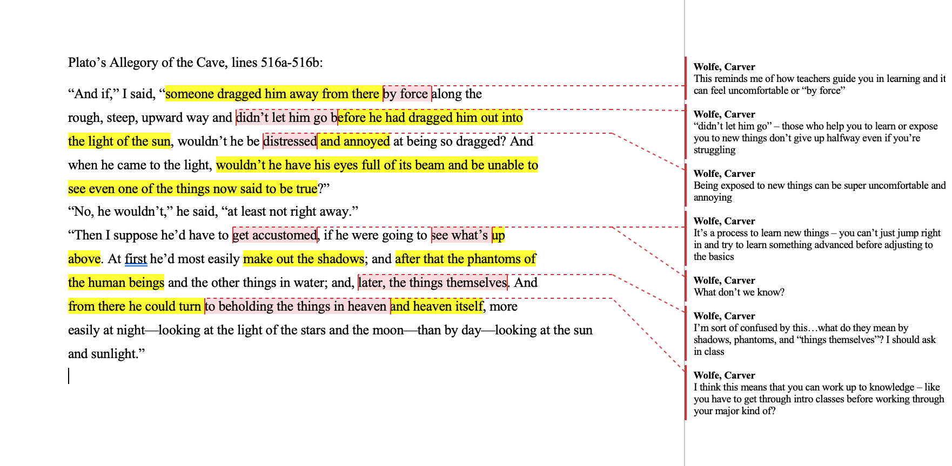
Below you’ll find an example of how you could have annotated the passage. Keep in mind that annotation is to help you understand the reading better – so everyone’s annotation style looks a little bit different. Here’s one way:

