Science in Motion
Ursinus College NAME _____________________________________
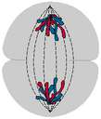
Mitosis and the Cell Cycle
“Breaking Up Is Hard To Do”

Standards:
3.1.10C – Describe how genetic information is inherited and expressed
Introduction
Mitosis is considered nuclear division, since its main stages deal strictly with the nucleus and its contents (DNA). Mitosis consists of 4 major stages: Prophase, Metaphase, Anaphase, and Telophase. Mitosis is part of a larger process called the cell cycle. When a living organism needs new cells to repair damage, grow, or just maintain its condition, cells undergo the cell cycle. Following mitosis the cell enters a stage called cytokinesis during which the cytoplasm and subsequently the cell divides. Between divisions, the cell is in interphase during which the cell grows, gains energy, and copies its DNA in preparation for the next division. The goal of this lab is to identify and collect pictures of the stages of the cell cycle and organize them in the proper order.

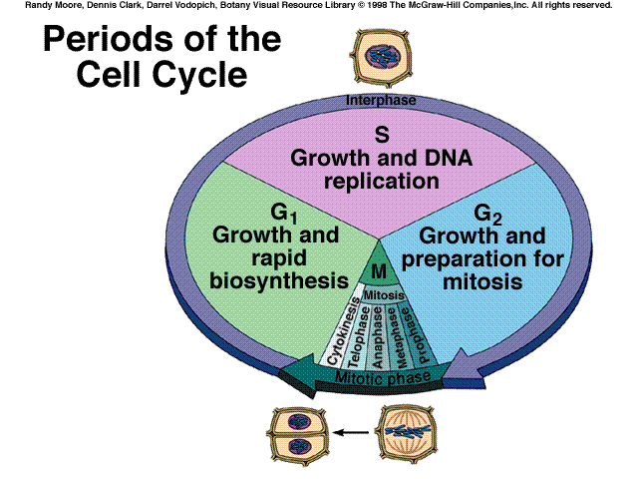

Materials:
Digital Microscopes
Whitefish blastula slides
Allium (onion) root tip slides

Procedure:

Whitefish Blastula – The blastula is an early embryonic stage in the development of animals. Cells are rapidly dividing at this time so it is a good medium to observe the cell cycle in animals. Whitefish is a general name for several species of fish including cod and haddock.
Getting Started
- You will be using the program ISCapture. If it is not already running, click on the orange ISCapture icon on your laptop screen.
- Turn on the green switch on the back of the microscope.
- Make sure your microscope is on the red 4X objective.
- Place your slide of the whitefish blastula in the mechanical stage.
- Use the coarse adjustment to move the stage up until it meets the stop.
- Use the coarse adjustment to turn the stage down until the image comes in focus.
- Use the fine adjustment to reach the best focus.
- On the computer, press the “White Balance” button to automatically adjust color.
- Move up to the 10X objective and start to look for a cell that would be a good representative of one of the stages of the cell cycle.
- When you find one, carefully move to the 40X objective and focus only using fine adjustment.
Taking a picture
- On the right side of your desktop is a tool bar. The 4th tool from the bottom is the crop tool. Crop your picture and then and click OK.
- Make sure the lighting and focus are perfect and then click capture/camera icon on the upper left of your screen.
- Your saved picture should show up at the bottom of your screen.
- Click on the return arrow on the right tool bar to continue your search for stages.
Prophase
Metaphase
Anaphase
Telophase
Cytokinesis
Interphase

Making the Cell Cycle Report
- After you have pictures of all the stages, minimize the program.
- Open the desktop file called “Cell Cycle Template”
and shrink the window.
- Your pictures are in a folder called “ISCapture Images.” Open it and shrink the window.
- Drag your best pictures over to the “Cell Cycle” page
- Label and organize the stages and add the names of the people in your lab group
- Print the page
- When the page prints, close the file but when it asks if you want to save say “no.”
- If you do not have time to print at the end the period, save the file on your desktop using your name and period as the title for the file.
Preparing for the next class
- Open the “ISCapture Images” folder that contains your pictures
- Make sure the “Home” tab is slected
- Click on “select all” at the top right of the page
- Click on the red x delete button
- All your pictures will be deleted
- Open the ISCapture program so the next class will be read to go
- Return the microscope to the 4X objective

Allium (onion) root tip
- Place a slide of Allium (onion) on the stage and focus just back from the tip with the 4X objective. The very tip of the root is called the root cap and is a protective layer but just behind the root cap is the most rapidly growing part of the root.
- There are several root tips on each slide. Choose one and focus on it using the 40X objective. Stages on the onion are sometimes harder to see than in the whitefish because the cells are smaller. Remember that the slide contains numerous cross sections and you may have to use several to find all the stages.
- Follow the same procedure you did with the whitefish. Print out you’re your page. Staple the two pages together and hand them to your teacher.

