Lab Quest 31
Pulleys
A pulley is a simple machine having a string that passes over a grooved wheel. A fixed pulley (See Figure 1) is attached to a solid support and changes the direction of force. The resistance force is the weight of the object being lifted. This force is applied to one end of the string that goes over a fixed pulley. The effort force is exerted on the other end of the string, in opposition to the resistance force.

A moveable pulley (see Figure 2) moves along the string with the resistance force, and the direction of the force is not changed. A pulley system may have a single pulley or a combination of pulleys (see Figure 3). Pulley systems are used to make work easier.

Mechanical advantage is a value that tells the number of times a machine increases the applied force. In this experiment, you will use a Force Sensor to measure the effort force (in N) for three different pulley systems and then determine the mechanical advantage of each system.

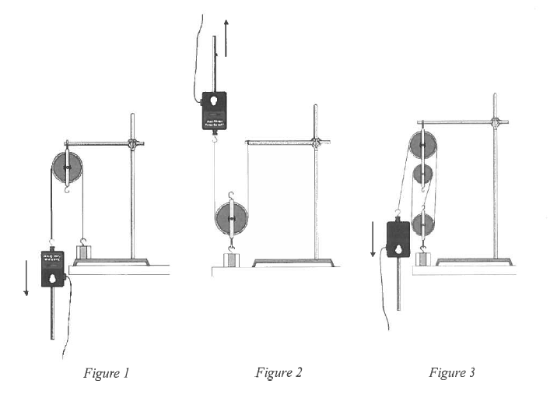
OBJECTIVES
- Use a Force Sensor to measure force
- Calculate actual mechanical advantage and ideal mechanical advantage.
- Determine efficiency.
- Make conclusions about pulley systems.

MATERIALS
Vernier LabQuest
Vernier Force Sensor
500 g mass
String
Single pulley
Double pulley
Ring stand
Utility clamp
Ruler

PROCEDURE
Pulley System 1
- Attach the metal rod (handle) onto the top of the force sensor.
- Connect the sensor to the LabQuest. Set the range switch on the Dual-Range Force Sensor to 10 N.
- Zero the Force Sensor with its hook pointing down:
  - Hold the Force Sensor in a vertical position with its hook pointing down. Make sure the hook is not touching anything.
  - On the LabQuest, tap the red “CH1: Force” box and select “zero”.
- Hang the mass to be used as the resistance from the Force Sensor. After the readings have stabilized, read the force (in N). This is the resistance force (F_{r}) for all three pulley systems to be studied. Record this value in all three resistance-force blanks in the data table.
- Zero the Force Sensor with its hook pointing up:
  - Hold the Force Sensor in a vertical position with its hook pointing up. Rest the tip of its handle on the tabletop.
  - On the LabQuest, tap the red “CH1: Force” box and select “zero”.
- Set up Pulley System 1. Attach a single pulley to a utility clamp as shown in Figure 1.
- Attach the Force Sensor to one end of the string and the resistance to the other end Rest the resistance on the tabletop.
- Raise the resistance 5 cm from the tabletop by pulling with the Force Sensor in the direction indicated in the figure (straight down for Pulley System 1). Read and record the effort force.

Pulley System 2
- Zero the Force Sensor with its hook pointing down:
  - Hold the Force Sensor in a vertical position with its hook pointing down. Make sure the hook is not touching anything.
  - On the LabQuest, tap the red “CH1: Force” box and select “zero”.
- Set up Pulley System 2 as shown in Figure 2. Repeat Step 8.

Pulley System 3
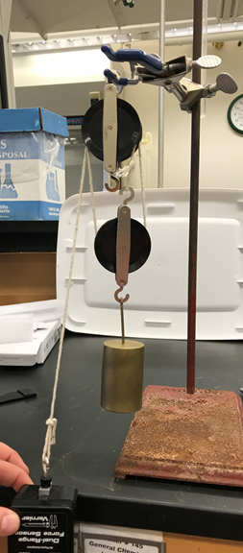
- Zero the Force Sensor with its hook pointing up:
  - Hold the Force Sensor in a vertical position with its hook pointing up. Rest the tip of its handle on the tabletop.
  - On the LabQuest, tap the red “CH1: Force” box and select “zero”.
- Set up Pulley System 3. Our equipment varies slightly from Figure 3. Our double pulley is side-by-side rather than stacked as shown in Figure 3. Refer to Figure 4 if necessary. Repeat step 8.
- Look at Figures 1-3 and count the supporting strings for each pulley system. All strings are considered to be supporting except a strong that you pull downward (with the Force Sensor). A string that you pull upward counts as a supporting string. Record these numbers.

Figure 4

DATA
Table 1
Pulley System | Resistance Force (N) | Effort Force (N) | Supporting Strings
1
2
3

PROCESSING THE DATA
- Calculate the actual mechanical advantage for each pulley system using the formula
$$AMA=\frac{Fr}{Fe}$$
Where AMA = actual mechanical advantage, F_{r} = resistance force, and F_{e} = effort force. Show you work below. Record results in the table that follows Question 3.
- The ideal mechanical advantage of a pulley is equal to the number of supporting strings. See the supporting string numbers in your data table and record the IMA values in the table following Question 3.
- The efficiency of each pulley system can be calculated using the formula
$$efficiency= \frac{AMA}{IMA} x 100$$
Calculate the efficiency of each pulley system. Record the results in Table 2.

Table 2
Pulley System | AMA | IMA | Efficiency (%)
1
2
3

- How did the mechanical advantage of the single-movable pulley (Pulley System 2) compare to the mechanical advantage of the single-fixed pulley (Pulley System 1)?
- How did increasing the number of pulleys affect the effort needed to raise the resistance?
- Diagram a pulley system (different from the ones used in this experiment) that has a mechanical advantage of 2.
- Discuss two factors that might have caused the efficiency values in this experiment not to be 100%.

EXTENSIONS
- Test the pulley system you designed in Question 6. Calculate its AMA, IMA, and efficiency.
- Design and test pulley systems with higher mechanical advantages.

