LabQuest 36
Crash Test Dummies

What happens to people in automobile collisions is important for car manufacturers. Crash dummies are often used in collision studies. Velocity is one of the most important factors in such collision studies. In this experiment, you will study the relationship between car velocity and the distance a “crash dummy” is thrown during a collision. A Motion Detector will be used to measure car velocity. You will use a ruler to measure the distance a crash dummy is thrown.

OBJECTIVES
- Measure velocity.
- Measure distances an action figure is thrown.
- Calculate averages.
- Graph the results.
- Make conclusions from your results.
MATERIALS (per station)
Vernier LabQuest
Vernier Motion Detector
1.5 m board
Car
1 3x5” index card cut to size
Small action figure (10-12 cm tall)
Two ring stands at least 45cm tall
Clamps and metal bar to stretch between the ring stands
1 Meter stick
2 standard rulers
Tape (painter’s blue)
Rubber bands or string (for seat belts)
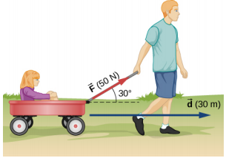

Figure 1
PROCEDURE
- Prepare the ramp
  - Set up a ramp on the bar connecting the ring stands as shown in Figure 1. The high end of the ramp should be 45 cm above the floor.
  - Make sure the ramp has cm distances marked on it, measured from the bottom (particularly 40cm, 60cm, and 80cm).
  - Use tape to mark a distance 30 cm from the bottom end of the ramp. Tape the ruler edge-up on the 30 cm line where it will be struck head-on by a car rolling off the ramp. You will also need to hold the ruler during each run so that it will not move when struck.
  - Fasten the Vernier Motion Detector at the top and center of the ramp as shown in Figure 1. Connect the Motion Detector to the LabQuest.

- Prepare a car for data collection.
  - Tape an index card to the back of a car. This card serves as a reflector for the Motion Detector.
  - Position the action figure (crash dummy) standing up in the car.

- Collect data.
  - Place your car on the ramp with its front wheels at the 40 cm line.
  - Click the green Δ button in the bottom left corner of the LabQuest, and then release the cart. Note: The car should hit the ruler while you are holding the ruler in place.
  - When data collection has ended, click on the peak of the first (leftmost) peak on the graph of the LabQuest (corresponding with when the cart hit the ruler). Read the velocity from the right side of the screen, and record it in Data Table 1.
  - Measure the distance the crash dummy was thrown (to the nearest cm). Record this value in Data Table 1. Measure from the front of the car to the nearest part of the action figure.

- Repeat Step 3 two times for a total of three trials at the same starting distance.

- Repeat Steps 3 and 4 with the front of the cart at the 60 cm position (Table 2) and again with the front of the cart at the 80cm position (Table 3).
DATA
Table 1: Release point of 40cm
 | Velocity when cart hit ruler (m/s) | Distance figure was thrown (cm)
Trial 1
Trial 2
Trial 3

Table 2: Release point of 60cm
 | Velocity when cart hit ruler (m/s) | Distance figure was thrown (cm)
Trial 1
Trial 2
Trial 3

Table 3: Release point of 80cm
 | Velocity when cart hit ruler (m/s) | Distance figure was thrown (cm)
Trial 1
Trial 2
Trial 3

PROCESSING THE DATA
- Calculate the average velocity for each release point. Record the results in Table 4.
- Calculate the average distance that the crash dummy was thrown for each release point. Record the results in Table 4.
- Graph your results using the average values in Table 4. Plot Velocity (in m/s) on the horizontal or x-axis and Distance Thrown (in cm) on the vertical or y-axis.

Table 4: Average values for 40, 60, 80cm
Starting distance (cm) | Average velocity when cart hit ruler (m/s) | Average distance figure was thrown (cm)
40 cm
60 cm
80 cm
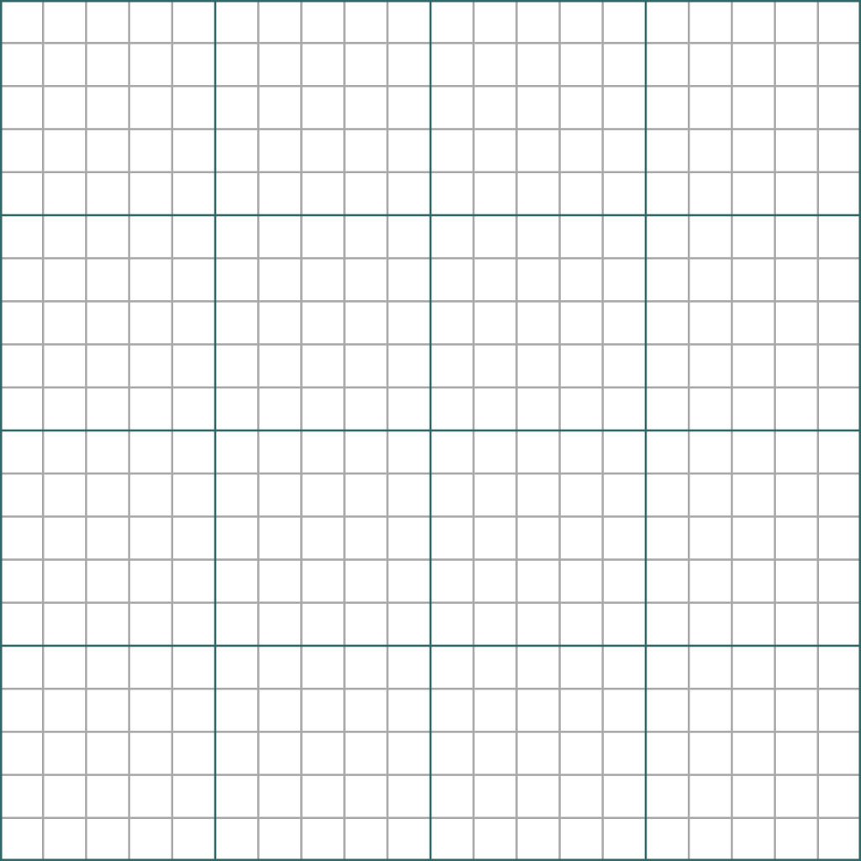
- What happened to the velocity of your car as it was released from higher release points?
- How did increased velocity affect the distance that your crash dummy was thrown?
- Do you think there would be more serious injuries in a high-speed or a low-speed collision? Explain.
- What is the purpose of seat belts?
PART II: SEAT BELTS
- Fashion a seat belt for your crash test dummy using rubber bands or string.

- Collect data.
  - Place your car on the ramp with its front wheels at the 80 cm line.
  - Release the cart (you do not need the LabQuest). Note: The car should hit the book.
  - Measure the distance the crash dummy was thrown (to the nearest cm). Record this value in Data Table 5. Measure from the seat of the car to the farthest part of the action figure.

- Repeat Step 2 two times for a total of three trials at the same starting distance.
Table 5: Distance Thrown (cm) while wearing a seat belt
Release point | 80 cm
Trial 1
Trial 2
Trial 3
Average

- Did the seat belt “work”? Explain your results and compare them to the 80cm distance thrown without a seatbelt.

