PAYMENT PLAN STEP BY STEP INSTRUCTIONS
www.ursinus.edu/paymentplan

How do I begin enrollment in a plan for the term?

* Enrollment opens on July 1 for the Fall term and on December 1 for the Spring term.

1. Enter the relevant account information; for example, Student ID or Last Name.
2. Click Continue.
3. Select an available plan for the term.

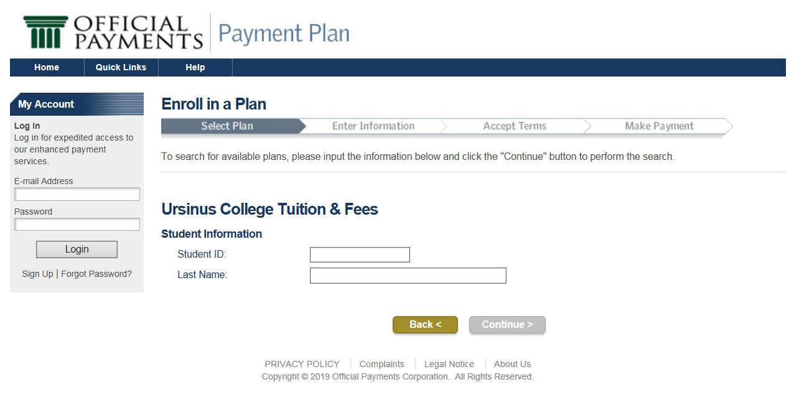

Enter payment plan information
Use the following steps to enter your Payment Plan information:
1. Review the Current Balance and your Estimated Financial Aid.

Once calculated, you will see any fees or payments due at enrollment in addition to the
future installment amounts and due dates.

2. You may clear the check box to opt out of scheduling future installment payments.

3. Click Continue.
If you are already logged in to My Account, the Accept Terms page displays. If you are not
logged in to My Account, the Identify User page displays and you will need to set up your account with log-in and password (see instructions at end of document).

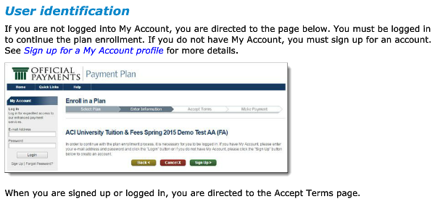

Accept payment plan terms
On the Accept Terms page, your plan details display.

You must:
1. Review the Retail Installment Contract.
Note: Click Save/Print PDF to open the contract in PDF format.
2. Select the “I accept” check box at the bottom of the contract to accept the Retail Installment
Contract.
3. Click Continue.
• If you selected to schedule automatic payments, you are directed to schedule your
payments.
• If you did not select to schedule automatic payments, you are directed to the Make
Payment page.

Make a payment
After agreeing to a plan, you must make a payment. Provide payment and payer information before submitting the payment.

1. Review
2. Select your payment method.
Note: If you pay with a stored account (also called an e-wallet account), the payment
flow skips ahead to the Review and Submit Payment page.
3. Click Make Payment.
The enrollment and payment process is complete. Your plan status is set to Pending, and you are directed to the payment application to pay for the items in Today’s Payment.
4. Provide payment information and complete the payment flow.

Provide payment information

After you click Make Payment, the Provide Payment Information page displays.
1. Select your payment method.
2. Enter the relevant account information.
3. Click Continue.
4. Click Accept Terms.

The Review and Accept Terms information displays.

1. Enter the following information:
• Name
• Address
• City
• State
• Zip Code
• Email address
2. Click Continue.
The Review & Submit page displays.

Use the following steps to submit the payment:
1. Verify the items and amounts to be included in the payment.
2. Click Submit Payment & the success window displays.

How Do I Sign Up for a My Account profile?

My Account

Before finishing your plan enrollment, you must sign up for My Account.
1. If not already directed here by the Payment Plan enrollment process, click Sign Up on the My Account panel.
The My Profile page displays.



