Payment Plans – FAQs:
How Do I Log in to My Account?
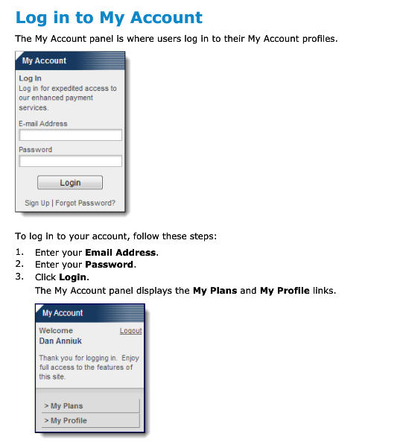

How Do I Recover a Forgotten Password?
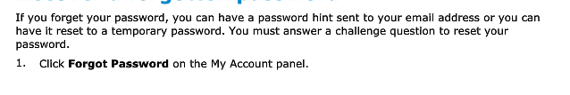
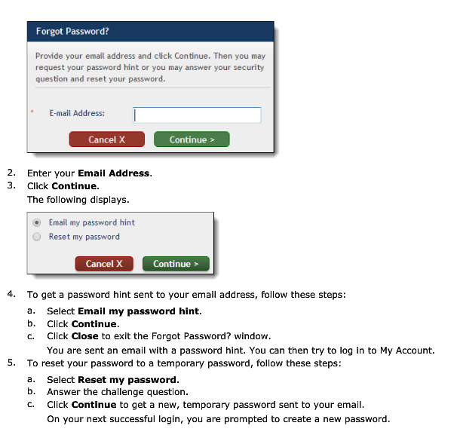

How Do I Change my Log-in Information?
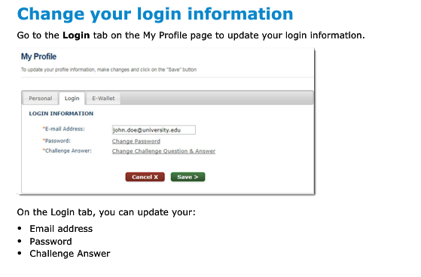
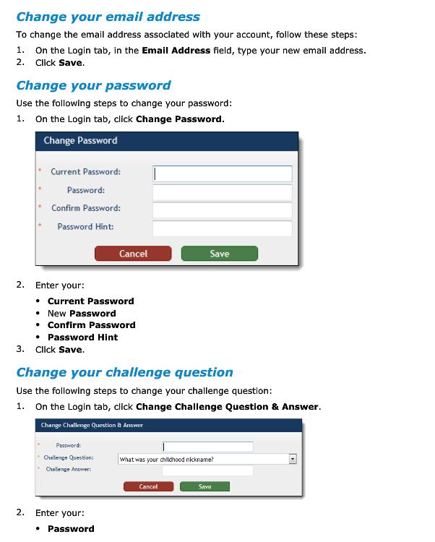

How Do I Add/Change E-Wallet Info?
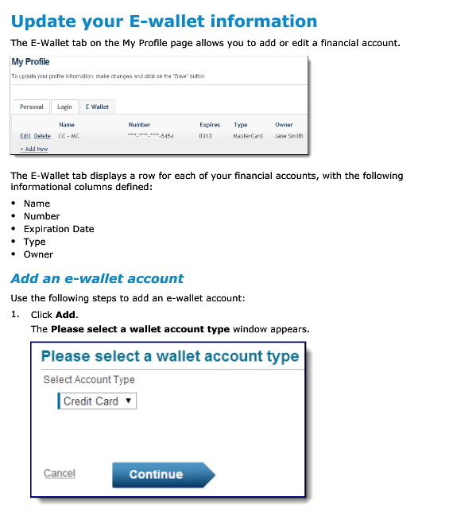
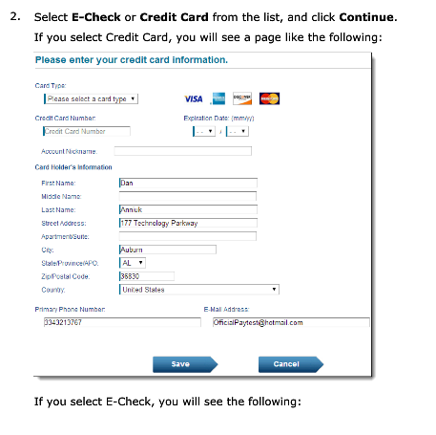
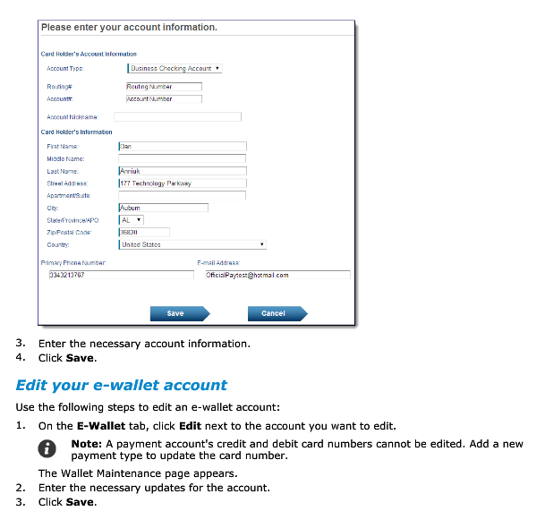

How Do I Schedule Payments?
**Please note, all payments are due on the 15th of each month. You may elect to change your payment date. If your monthly payment installment is not made by the 25th of each month, Official Payments will add a $5.00 late charge to your account.


