Using a Gas Chromatograph to
Identify Compounds in Forensics

There are many different types of chromatography: paper, thin layer, liquid, high-pressure liquid (HPLC) and gas (GC). Chromatography is applied in many fields. Biochemists use liquid chromatography to separate proteins; chemists use GC and HPLC to identify organic compounds. Technicians use GC for drug tests, toxin screens and environmental analysis. Many forensic tests involve chromatography.
All chromatography approaches operate under the same principles. There is a stationary phase and a mobile phase. The mobile phase travels along the stationary phase (in the column or on a plate) from a start point to an end point. Compounds can travel from the start to the end at different rates, depending on whether they tend to “stick” to the stationary phase or “float” in the mobile phase. Compounds stick to the stationary phase through dipole interactions, dispersion forces or ionic interactions.
The Vernier Mini GC uses a metal column with the inside of the column coated with the stationary phase. A sample, consisting of one or more compounds, is injected onto the column and is pushed through by air, which acts as the mobile phase. Organic compounds flowing out of the chromatography column are seen as a peak on a chromatograph, as seen in Figure 1. The amount of time it takes for a compound to exit the column after it is injected is called the retention time. With a GC, a compound can be identified from a mixture of chemicals by its retention time.
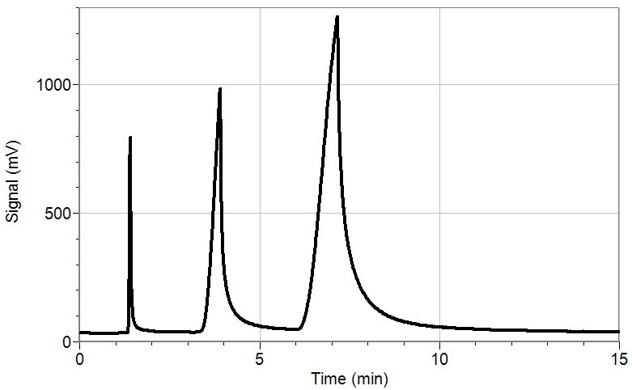

Figure 1. Sample gas chromatogram

Several factors can affect the interaction of a compound with the GC. More volatile compounds (i.e., compounds with a lower boiling point) tend to move through the column faster because they are flowing in the mobile phase and interacting very little with the stationary phase. The functional groups present on the compound are also a factor. For example, alcohols may interact with a polar stationary phase more than esters because alcohols can form stronger hydrogen bonds. The molecular weight of a compound can also play a role, although it is not a simple matter of saying that the heavier the molecule, the slower it will travel through a GC column.
OBJECTIVES
In this experiment, you will
- Measure and analyze the retention time of three ketones and an unknown crime scene sample as they pass through a Vernier Mini GC.
- Identify the crime scene ketone based on retention time.

MATERIALS
Vernier Mini GC | acetone
LabQuest | 2-butanone (methyl ethyl ketone)
LabQuest App | 2-pentanone
1 μL glass syringe
Kimwipes® | unknown crime scene ketone

PRE-LAB EXERCISE
Complete the table below. Look up the boiling points for the ketones listed and predict the order in which these compounds will exit the GC column (known as elution order). Rate the compound you think will exit the column first with the number 1; the last compound to exit the column is given the number 3.

Compound | Boiling point (°C) | Predicted elution order  (1–3)
2-butanone
acetone
2-pentanone

PROCEDURE
1. Obtain and wear goggles.
2. Obtain a glass syringe and a set of vials containing the 3 ketones and a crime scene unknown to be tested. You will not only test acetone but use it to clean the syringe needle.
Important: The glass syringe is fragile and can be easily damaged. Be careful not to bend the needle or bend the plunger. If the plunger is accidentally pulled out of the glass barrel, reinserting it is extremely difficult, and sometimes impossible.
3. Prepare the Vernier Mini GC for data collection.
- Turn on the Mini GC.
- Connect the USB cable of the Mini GC to the USB port on your LabQuest.
- Choose New from the File menu.
- Tap ► in LabQuest, to bring up the Temperature-Pressure profile.
- Set the Temperature-Pressure values to:

Start temperature | 35°C
Hold time | 2 min
Ramp rate | 5°C/min
Final temperature | 55°C
Hold time | 0 min
Total length | 6 min
Pressure | 5.0 kPa

- Select Done to initiate the Mini GC warm up. Note: A new message will appear, “Do not inject until GC is ready,” and the LED on the Mini GC is red. The Mini GC will take a few minutes to warm up and stabilize. When the Mini GC is ready for injection in Step 7, the message will read, “Inject and select Collect simultaneously,” and the LED will turn to green. Continue with Step 4 during warm up.

4. Follow the steps below to clean and flush the syringe with acetone. Important: The glass syringe is fragile. Be careful not to bend the needle or bend the plunger. Never pull the plunger back more than 50% of its total volume. Be careful not to bend the plunger as you press it down.
- Depress the plunger fully.
- Submerge the tip of the syringe needle into the vial of acetone.
- Pull back the plunger to fill the barrel about 1/3 full of acetone. Examine the barrel of the syringe and estimate the amount of acetone in the barrel.
- Expel the liquid onto a Kimwipe or a paper towel.
- Repeat Steps a–d at least two times, until you are comfortable pulling up a liquid into the syringe and measuring the volume in the syringe barrel. Use a Kimwipe or a paper towel to carefully pat around the tip of the syringe needle.
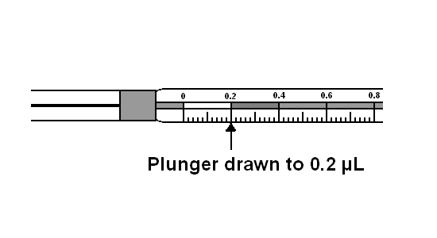
Figure 2
5. Follow the process in Step 4 to clean and flush the syringe with 2-butanone, the first ketone sample to be injected into the Mini GC.
6. Collect a volume of 2-butanone for injection.
- Submerge the needle into the vial of 2-butanone one last time.
- Draw up approximately 0.2 μL of liquid. It is not critical that the volume be exactly 0.2 μL; a tiny bit more or less volume is all right.
- After collecting your sample, use a Kimwipe to gently wipe the needle from barrel to tip.

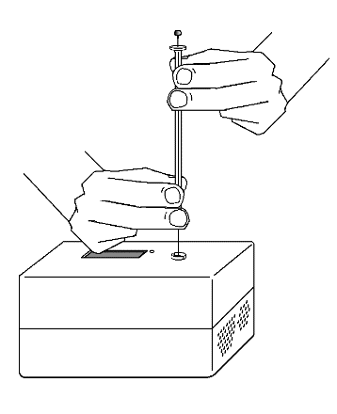
7. Prepare for injection and the start of data collection. It is important for you and your lab partner to divide the tasks in this step. One person will operate the syringe and the other person will operate the computer controls.
Figure 3
- When the Mini GC has reached the correct start temperature and pressure, the message reads, “Inject and select Collect simultaneously,” and the LED on the Mini GC is green.
- To insert the needle of the syringe into the injection port of the Mini GC, hold the syringe with one hand and steady the needle with your other hand. Insert the needle into the injection port until the needle stop is fully seated, as shown in Figure 3. If the needle sticks, rotate it slightly while inserting. Do not move the plunger yet.
- Simultaneously, depress the syringe plunger and select Collect to begin data collection. Pull the needle out of the injection port immediately.

8. While the data collection proceeds, repeat Step 4 using acetone to thoroughly clean the syringe and needle. It may take more than three flushes to feel the syringe plunger move smoothly again, which is your indicator that the syringe and needle are both suitably clean.
9. Data collection will end after 6 minutes. If you see a peak before the end of the 6 minute collection time, you can stop data collection early by tapping the stop icon (red square). Allow a full minute to pass after peak formation before hitting stop. This ensures the GC column is clean for the next sample.
10. Analyze your chromatogram.
- Choose Peak Integration from the Analyze menu. Choose Signal.
- Select and integrate the left-most peak. To do this, drag from a little before the peak to a point far enough to the right that includes all of the peak. Then choose Add.
- Record the retention time in the data table in this handout.
- Select OK.
12. Prepare to run another ketone sample (Acetone or 2-pentanone).
- Tap ► in LabQuest, to bring up the Temperature-Pressure profile. It will ask if you want to store or discard the latest run. Once you have recorded the retention time, select discard. The profile displayed will be the same as for your previous run. If you are satisfied with these values, select Done to initiate the Mini GC profile.
- While the Mini GC adjusts to its Temperature-Pressure profile, repeat Steps 4–6 with the next ketone sample (acetone or 2-pentanone).
- After the Mini GC is ready, repeat Steps 7–10 using your new ketone sample.

13. Repeat Step 12 for the remaining ketone sample and the crime scene unknown.
14. When you have completed your final data collection run, turn off the Mini GC and clean the syringe with acetone several times.

DATA TABLE
Compound | Boiling Point (°C) | Actual Elution Order (1-3) | Retention Time (min)
2-butanone
acetone
2-pentanone

Analysis of the Crime Scene Unknown

Retention Time: ____________________

Crime Scene sample identity: ___________________

