Approve and Reject Requisitions

For approvers if you have set up ‘My Account’ to receive emails, you will receive an email stating that there is a requistition to be approved.
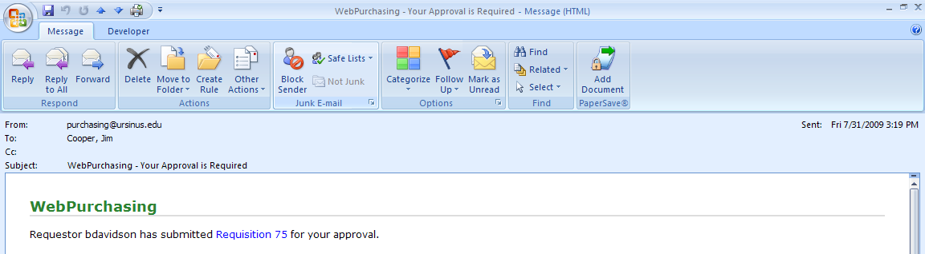

Login to Web Purchasing

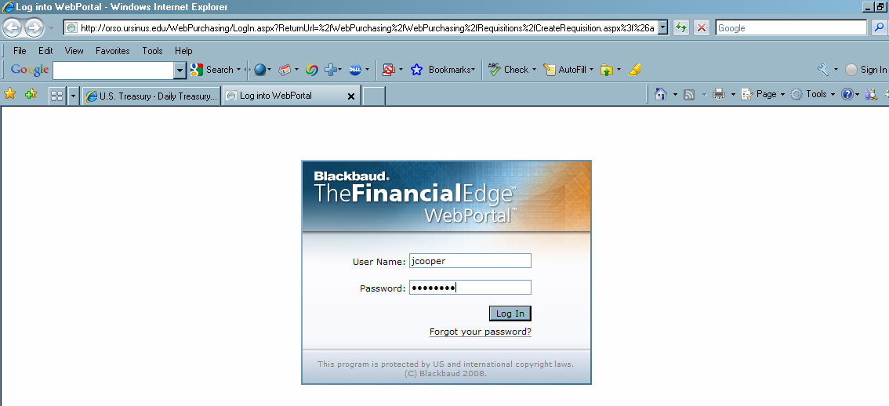

Click on ‘Requisitions for Review’.
The screen will show all the requisitions ready for your review and approval. Locate the requistion(s) that you want to review. Click on the ‘Review’ button next to the requistition that you want to review.

The Review Requisition page will appear.
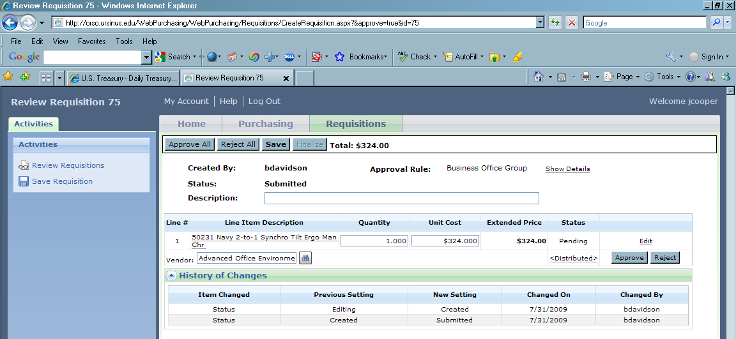

You can either ‘Approve All’ or ‘Reject All’.
You can, also, ‘Approve’ or ‘Reject’ by each line item.

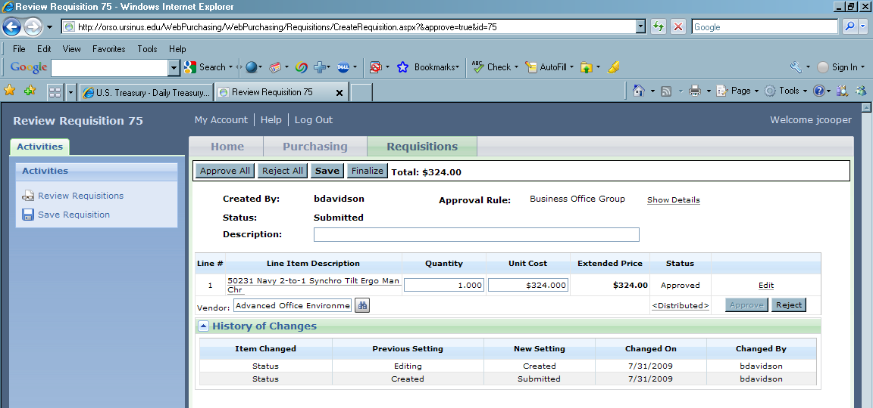

The Status column will change to ‘Approved’ or ‘Rejected’.

****The last step is to click on ‘Finalize’ to submit the requisition to the Purchasing Office.

Once all requisitions have been finalized your ‘Requisitions for Review’ page will show no requisitions.

